

# Level-up CSP Technical Training – Power Platform

**Use case –Automate Inventory management and Quality control app using Power Platform**

|  |  |
| --- | --- |
| Description | A hands-on experience to inspire users to use Microsoft Power Platform tools to design and implement digital systems to meet business objectives. |
| Prerequisites | To get the most out of this training we recommend you have admin access with Power Apps for Developer and Power Automate. |
| Audience | Microsoft partners will deliver this workshop to CSP customers, who have multiple employees in their company, have a Microsoft Power Apps for Developer and Microsoft Power Automate license, and have minimal Microsoft Power Platform experience. |
| Duration | 60 minutes |
| Publication date | September 2024 |

This document is provided “as-is”. Information and views expressed in this document, including URL and other Internet Web site references, may change without notice. You bear the risk of using it.

This document does not provide you with any legal rights to any intellectual property in any Microsoft product. You may copy and use this document for your internal reference purposes.

© 2024 Microsoft. All rights reserved.

Contents

Level-up CSP Technical Training – Power Platform 1

Objective and scenario 4

Objective 4

Solution focus area 4

Personas and scenario 4

Pre-requisites 5

Lab instructions 6

Exercise 1: Create an Inventory management app using Copilot. 6

Task 1: Verifying your Dataverse environment 6

Task 2: Create inventory management app using Copilot. 7

Task 3: Create candy quality Screen 18

Conclusion 34

Exercise 2: Create a Power Automate flow to restock the inventory. 34

Task 1: Create a Power platform flow to trigger restock email 35

Task 2: Test the restock flow 52

Conclusion 57

Exercise 3: Create a Power Automate flow to notify supplier when item is defective. 58

Task 1: Create Power Automate flow to notify the supplier when item is marked defective. 58

Task 2: Generate a defective product email to the supplier for approval. 71

Conclusion 75

# Objective and scenario

## Objective

Build an app using Power Apps and Copilot to digitalize Inventory Management and automatically restock products when inventory gets below a threshold. The app should notify the suppliers or production teams whenever an item is marked as defective.

## Solution focus area

Contoso Corp prides itself on providing customers with the highest quality products. To provide a seamless experience for the customers, Contoso needs a constant supply of inventory. To streamline the restocking process of the products, Contoso Corp aims to develop a customized application to automatically restock products when the inventory gets below a specified threshold. Additionally, to maintain product quality, Contoso needs to add a feature that notifies the suppliers or production teams whenever an item is marked as defective.

Contoso Corp needs a new solution that can:

* Create an app to raise an approval request when the inventory gets below a specified threshold.
* Automatically restock inventory products once the request is approved.
* Raise a notification to the supplier when the item is marked as defective.

## Personas and scenario

* **Remy Morris** - Digital Solutions Architect
* **Mark Brown** – Project lead
* **David Flores** – App developer
* **Jane Miller** – App tester

These personas will participate in the following sequential scenarios:

* Remy Morris, Digital Solutions Architect at Contoso Corp, creates and plans digital architecture that aligns with the business need and articulates this framework to Mark Brown, the Project Lead at Contoso Corp, and assists him in selecting the most suitable Power Platform tools for the implementation of the digital solutions.
* Mark Brown provides David Flores with an overview of the tools and processes involved in developing a canvas app using Power Apps and creating an approval flow using Power Automate.
* David successfully creates a canvas app and an approval flow, fulfilling all the requirements of Contoso Corp to streamline and automate the approval workflow for restocking inventory of products, which he then submits to Jane Miller for testing.
* After thorough testing and validation, Mark Brown officially hands over the app to the team, enabling them to use the Inventory management app efficiently.

# Pre-requisites

For this use case, all participants will need the following:

* Work, School or Admin Tenant Email Id and Password (To acquire Microsoft 365 Admin trial tenant, go to [Microsoft 365 E3](https://www.microsoft.com/en-us/microsoft-365/enterprise/e3?activetab=pivot%3Aoverviewtab%2F%3Fazure-portal%3Dtrue))
* [Microsoft Power Apps for Developer license](https://www.microsoft.com/en-in/power-platform/products/power-apps/free) (Includes Power Automate License)
* [Microsoft 365 Business Premium/E3/E5 license](https://www.microsoft.com/en-in/microsoft-365/business)
* Their own devices with Wi-Fi connection.

**Note**

Please be aware that the user interface (UI) of Power Apps, Power Automate, and other related tools may change over time as Microsoft continues to update its products. However, the core concepts and logic behind their functionality will remain consistent. The principles you learn in this lab can still be applied, even if the UI looks different in the future.

# Lab instructions

# Exercise 1: Create an Inventory management app using Copilot.

In this exercise, you will create an Inventory management app with the help of Copilot. Add re-order point column in Dataverse table and create Quality screen

## Task 1: Verifying your Dataverse environment

* 1. Open a browser and go to <https://admin.powerplatform.microsoft.com>. Sign in with your work /school/admin account.
  2. Select **Environments** on the left navigation. The **Developer environment** should have been created for you as shown in the image below. (This environment is created automatically as soon as you provide Microsoft Power App for Developer license using your work/school accounts. The name of the environment will be different for every admin account.)

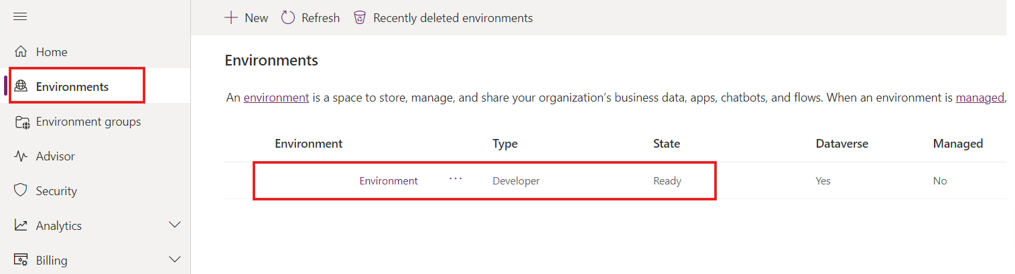

* 1. Use the same developer environment to execute all the exercises of this lab.

**Note**: **Dev one** developer environment is used in this lab. The name of the environment can be different for different users. Make sure to select your developer environment.

## Task 2: Create inventory management app using Copilot.

1. Open a browser and go to <https://apps.powerapps.com> and sign in with Work, School or admin tenant account.
2. Click on the environment on right top corner and select **your developer** environment (Dev one is a developer environment used in this lab guide)

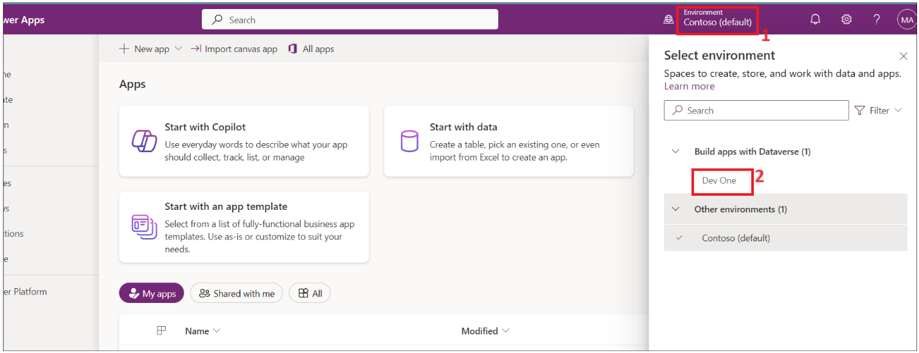

1. Enter the below prompt and click on **the Enter** button.

build a candy inventory management app

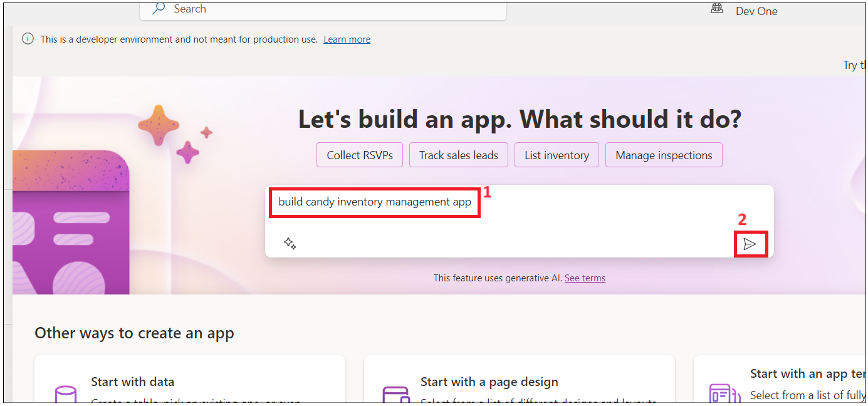

1. Select the **Start with Copilot** tile

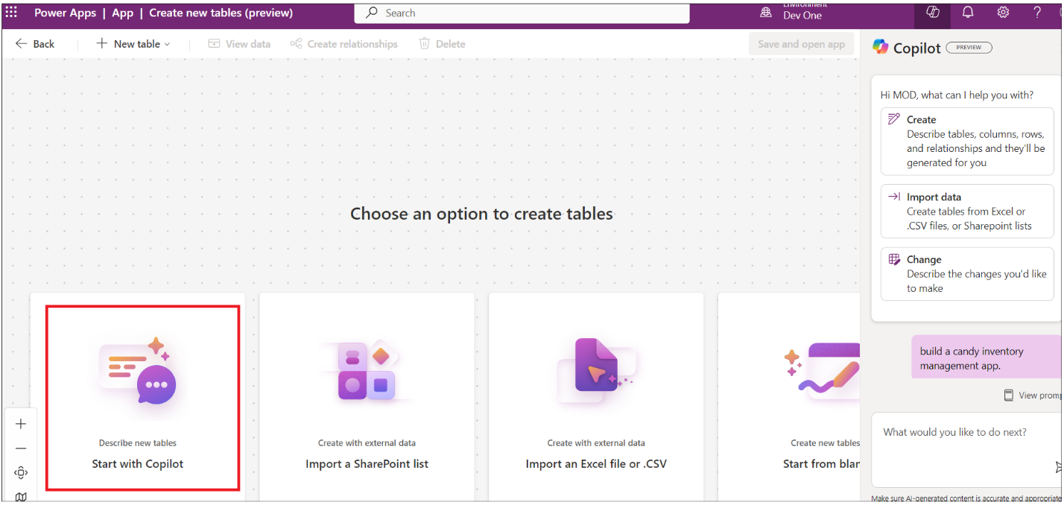

1. Enter below prompt and click on **Generate** to create table with the help of Copilot

**Candy Inventory management**

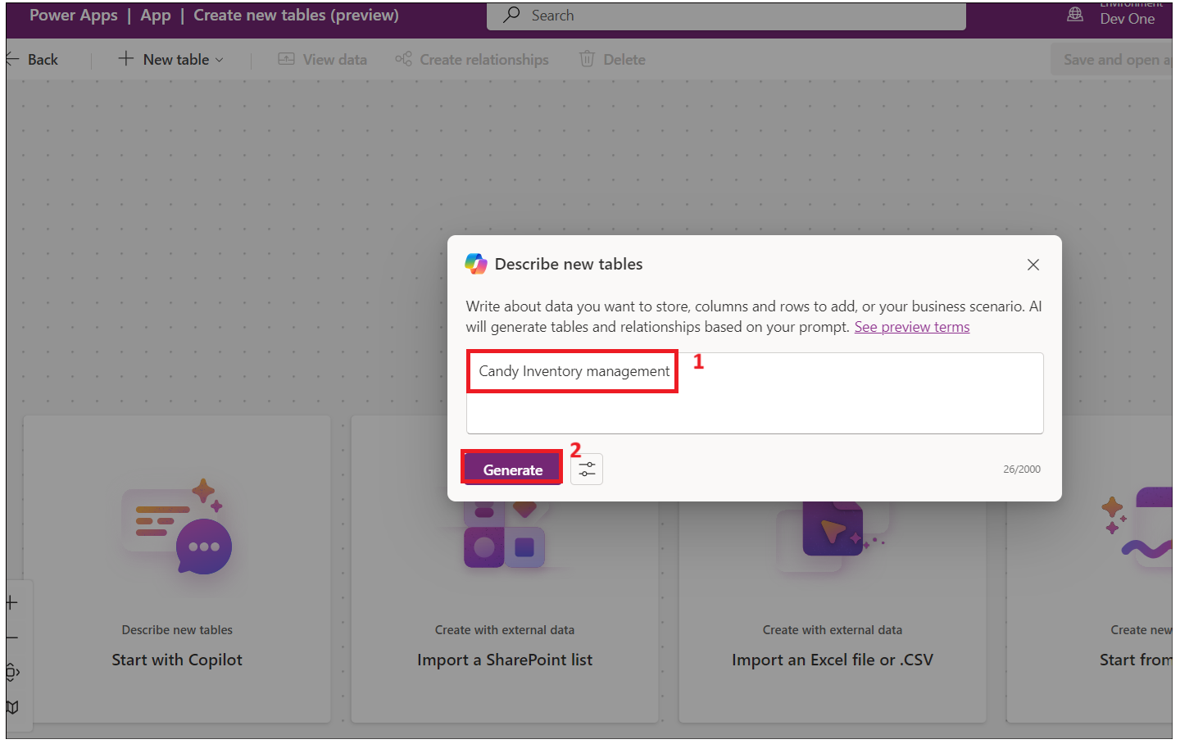

1. Copilot generates the tables as shown in the below image.

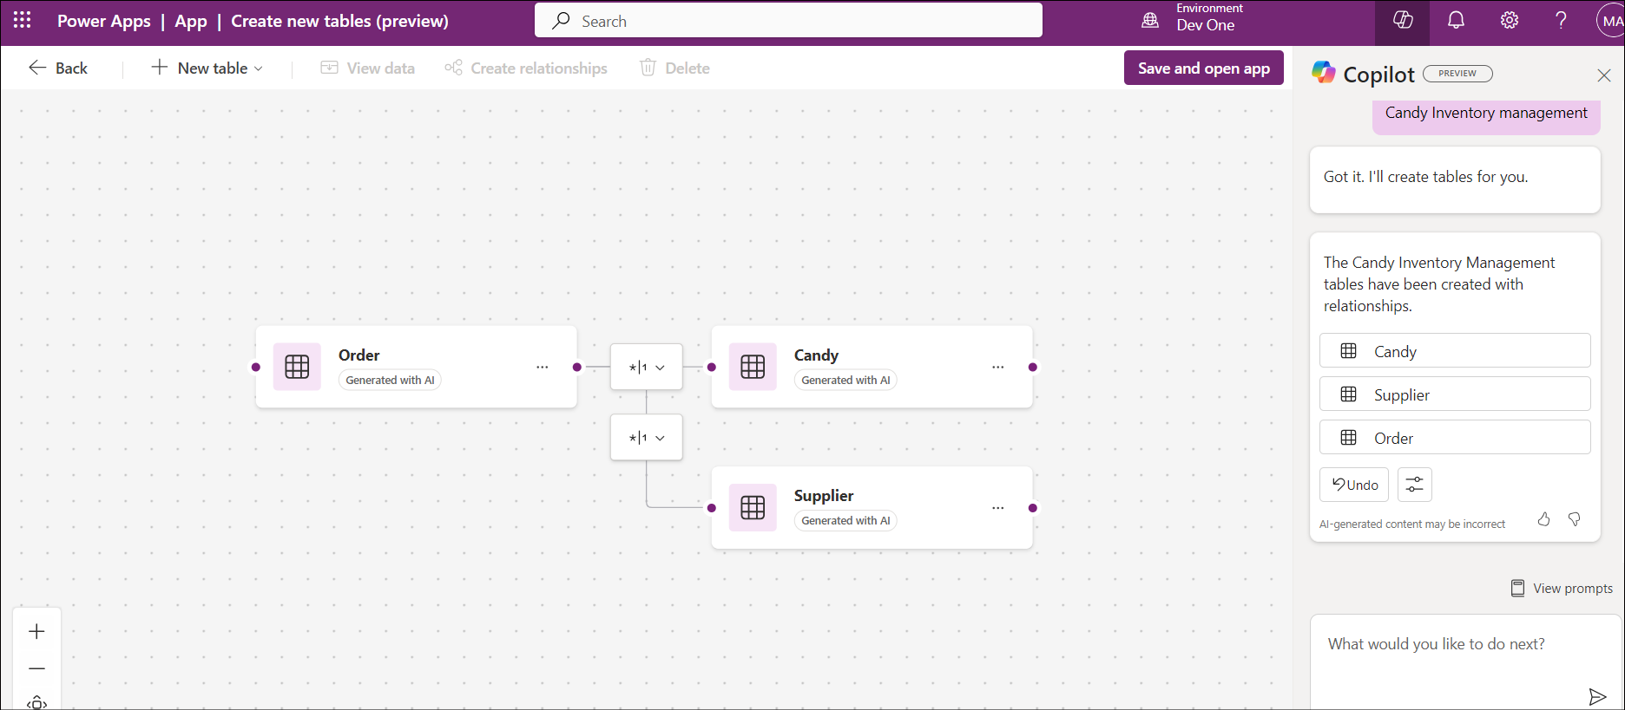

1. Click on three dots next to Candy and then click on **View data.**

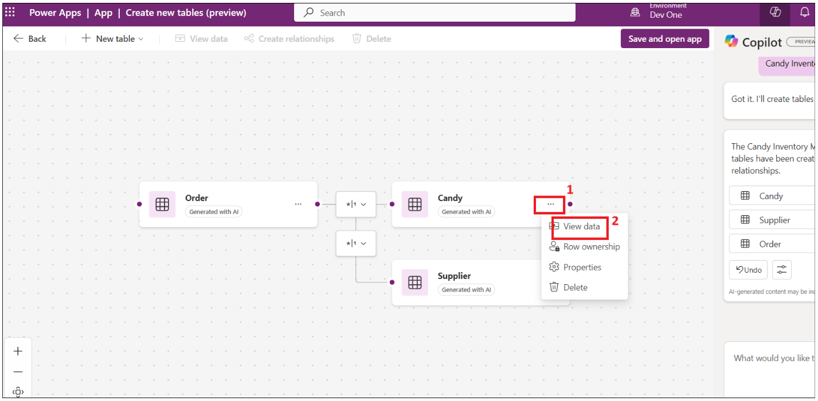

1. The data in the Candy table should have data as shown in the image below.

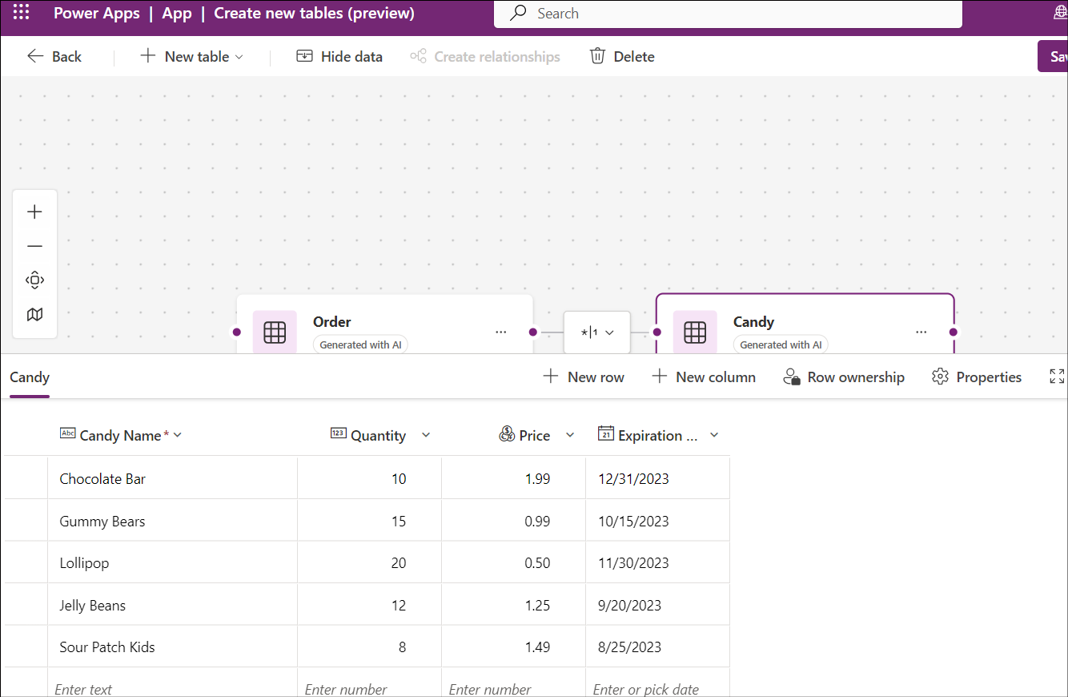

1. Click on **Supplier -> View data** and explore the data and then close the view window.

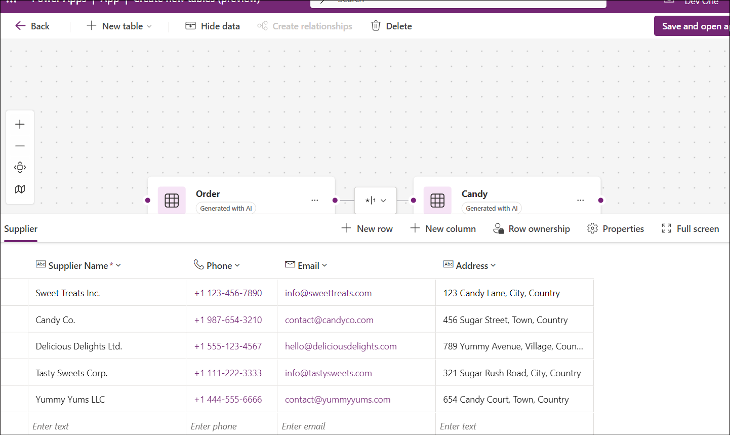

1. Update one of the Supplier email ids with your work/personal working email id

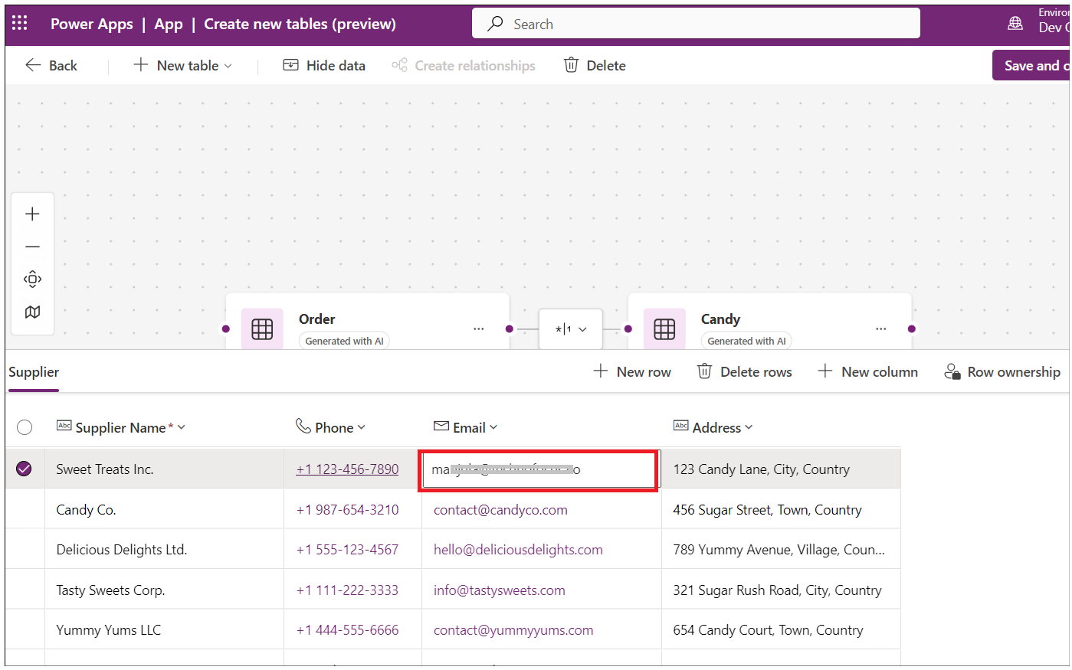

1. Click on **Order -> View data**

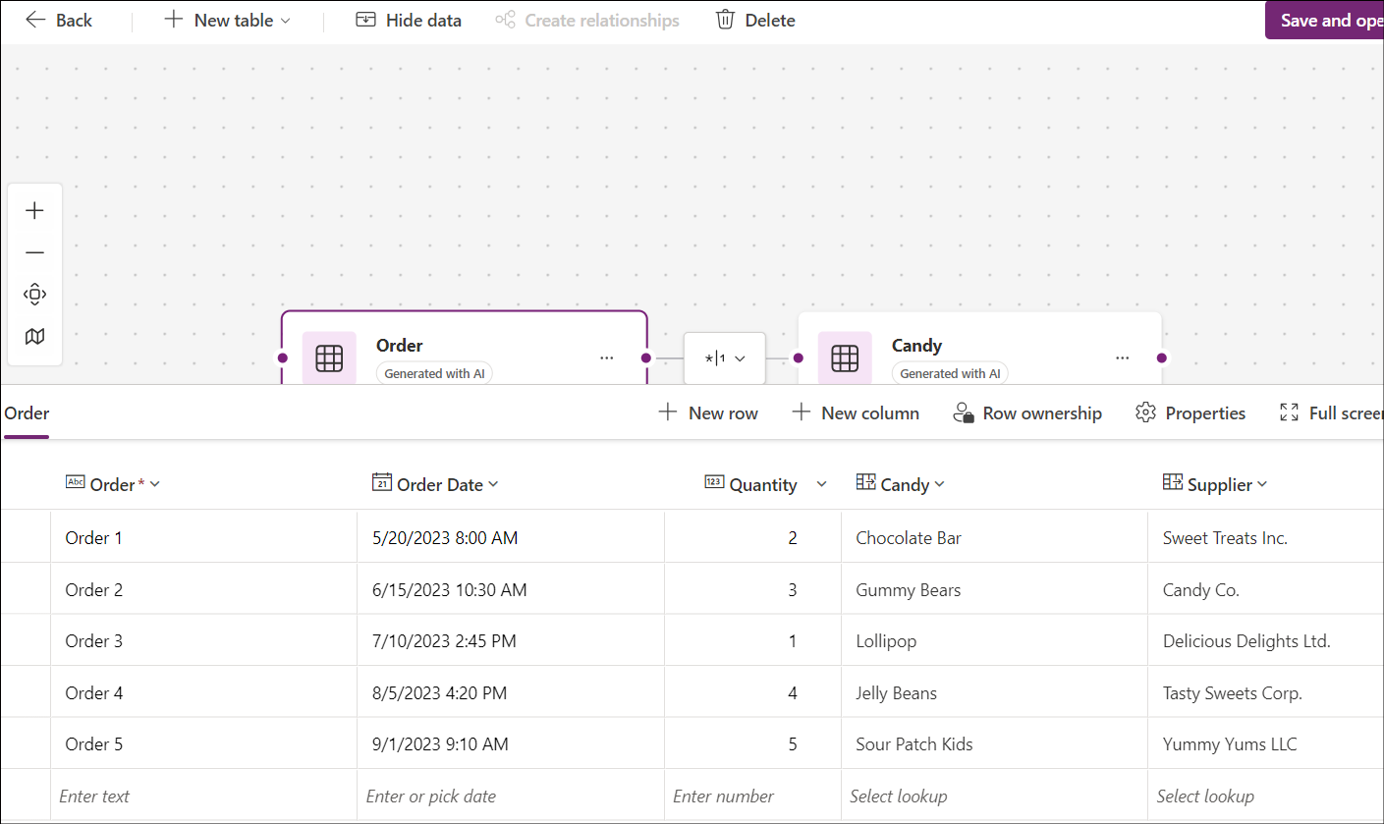

1. Ener below prompt in the text box and click on Enter. This column is required to notify when the quantity went below the reorder point.

Add reorder point column to Candy table

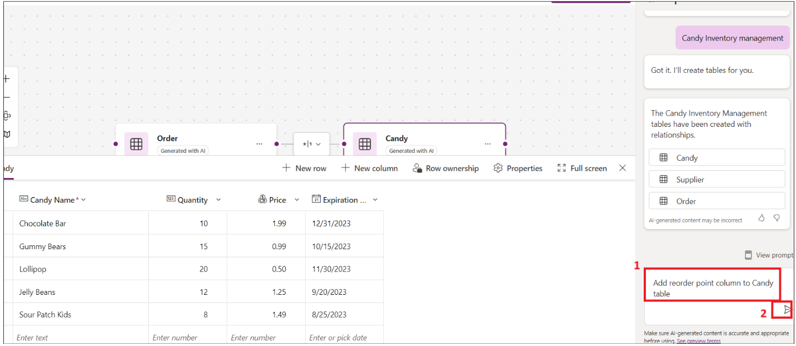

1. Add candyInStock column with type as Number. If Quantity is less than reorder points, then Quantity column will automate add with candyInStock.

Add **candyInStock** column to Candy table with sample stock count

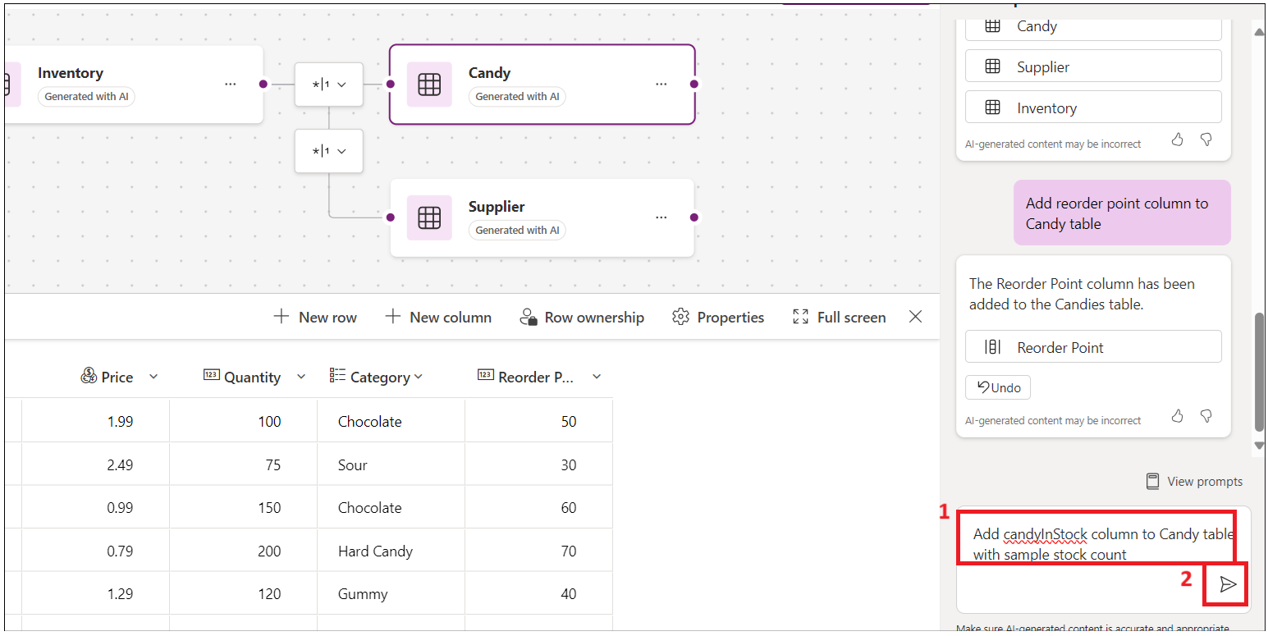

1. The table has been updated with reorder point column and Candy in Stock column

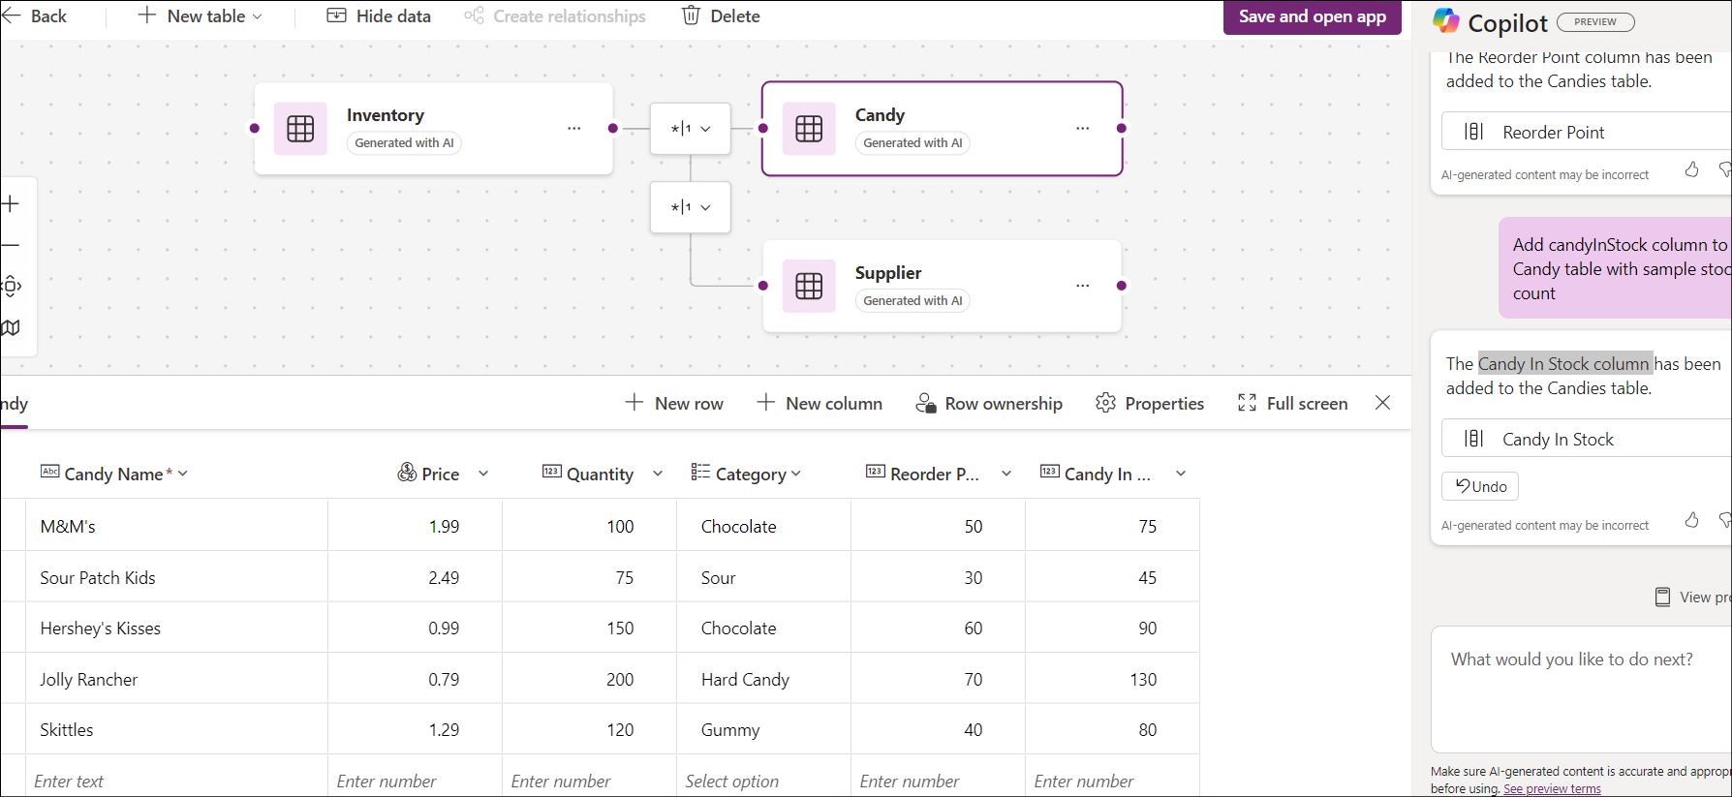

1. Click on the **Save and open app** button

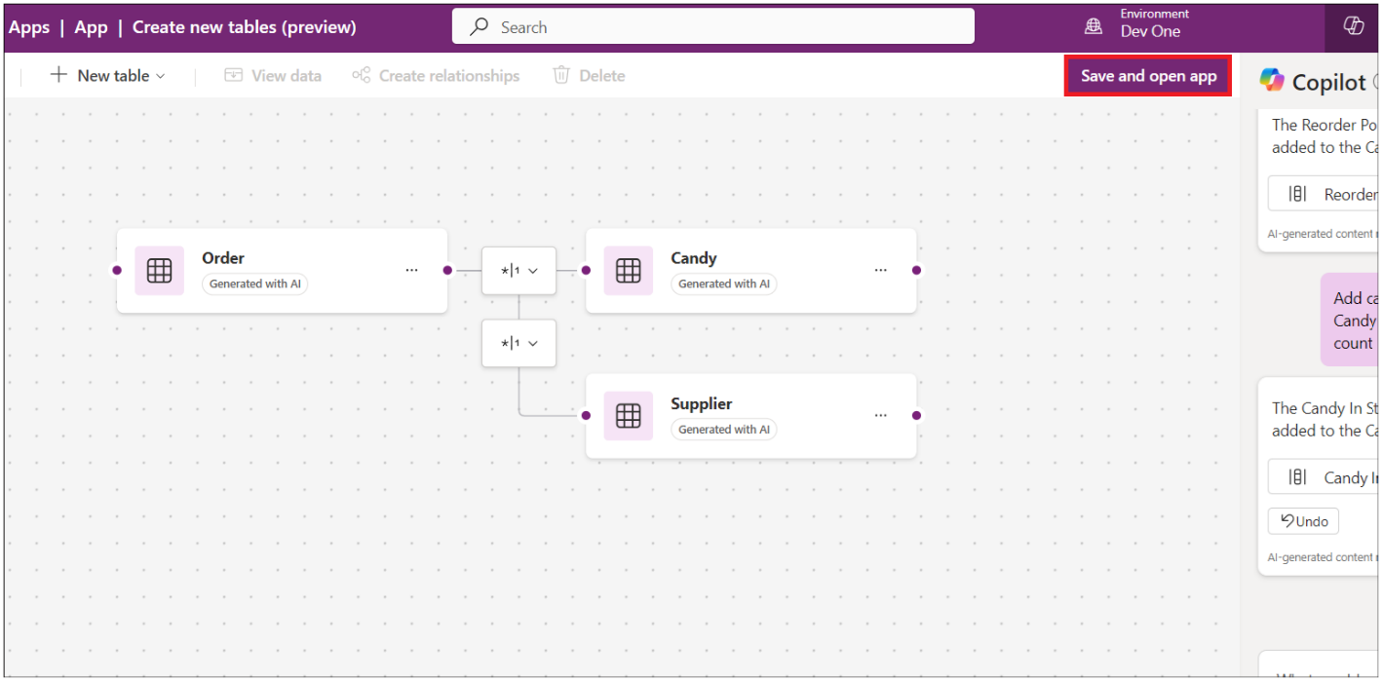

1. On **Done working?** window, click on **Save and open app** and wait for the app to be created.

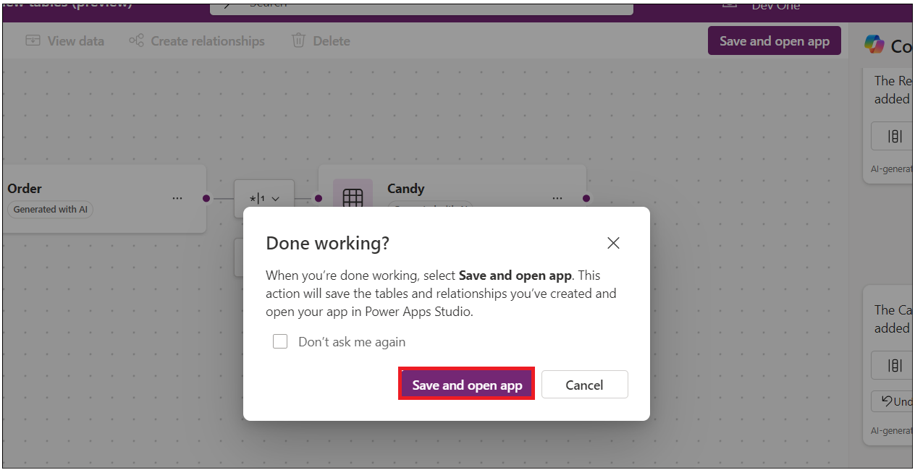

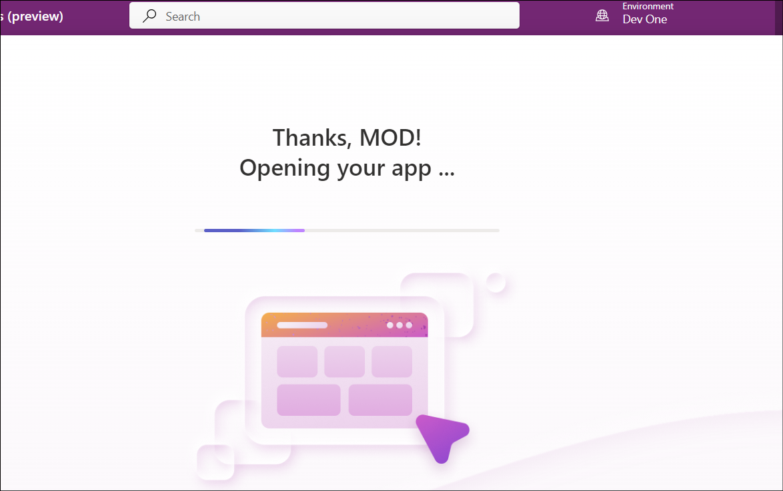

1. Skip the welcome window.

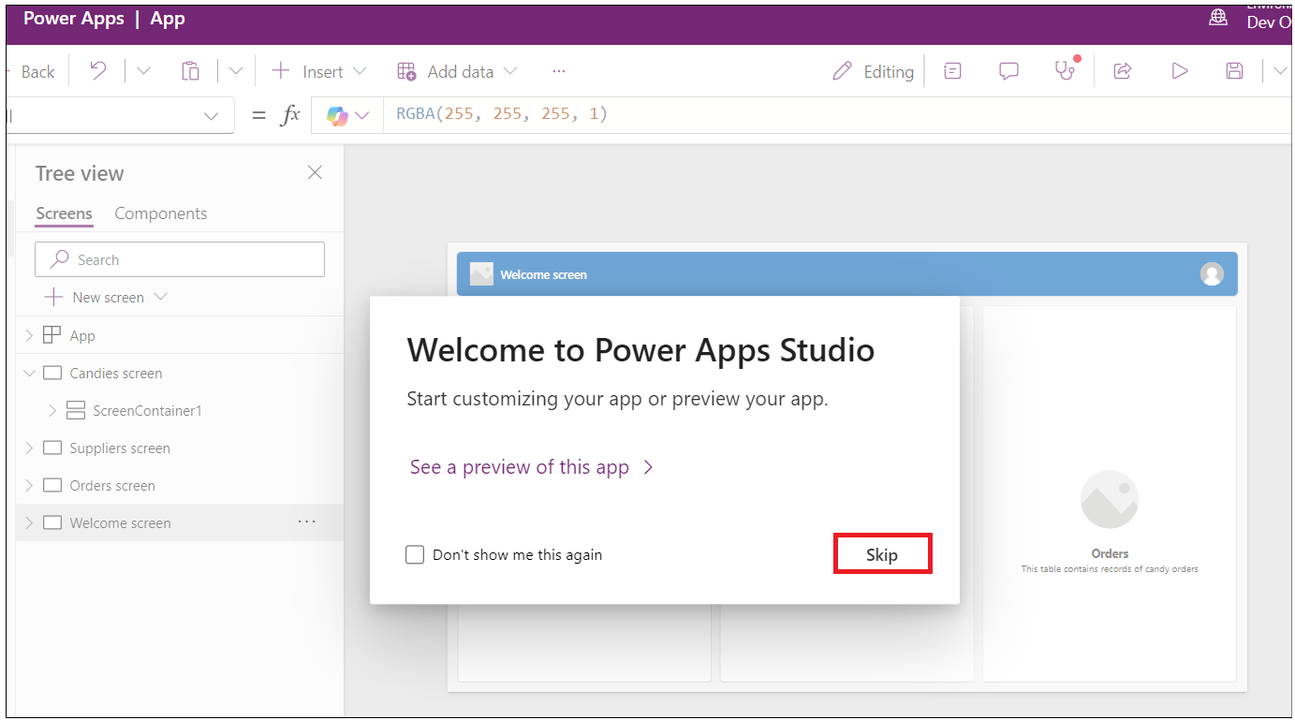

1. The app gets created and should look like the image below.

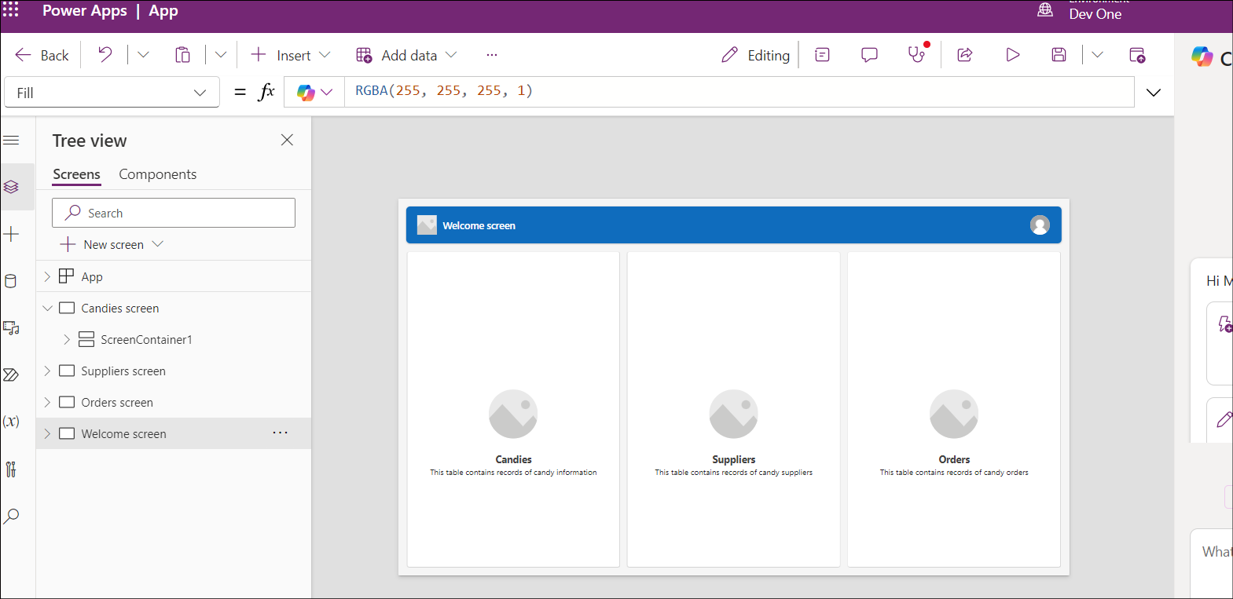

1. Click on the **save** button and enter the name **MSCandy Inventory management app**, then click on **Save** button.

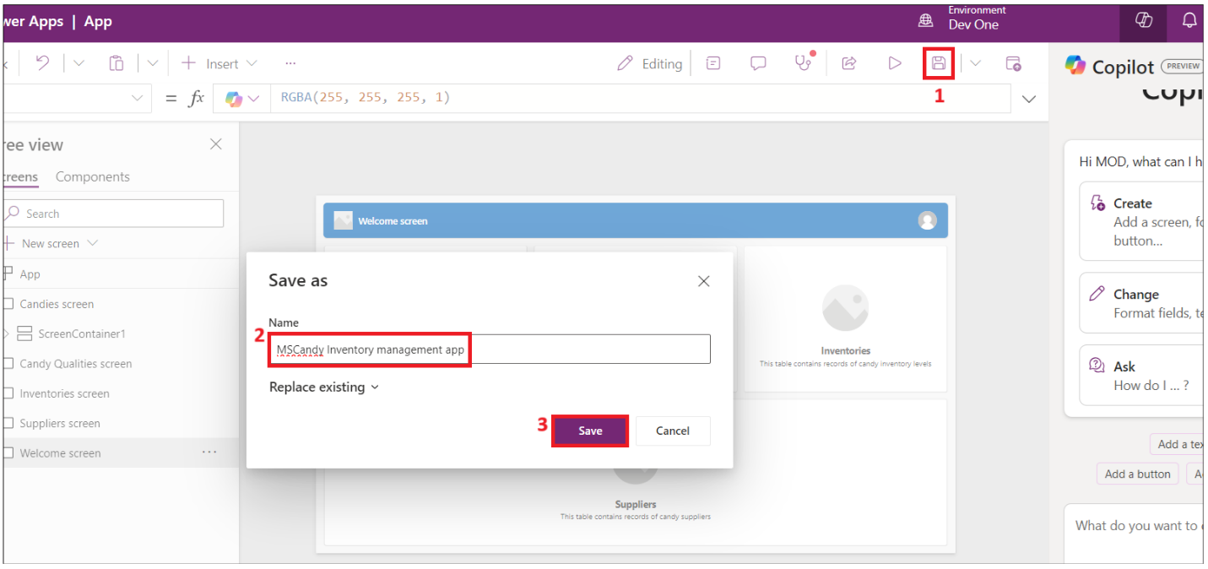

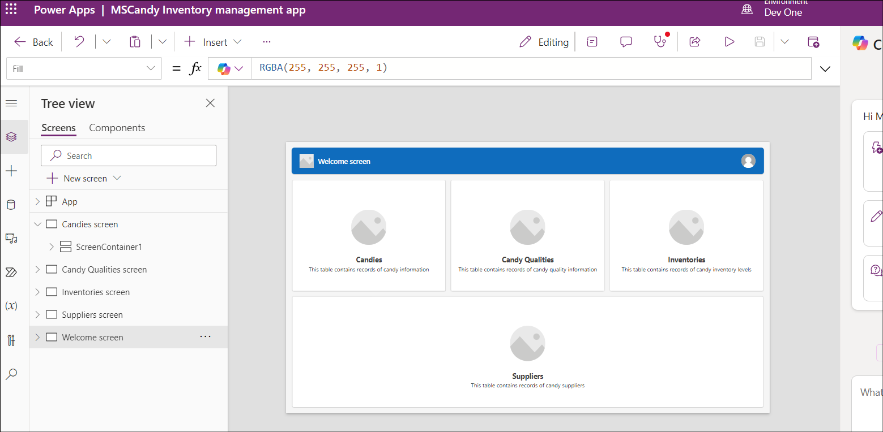

1. Explore the app. Click on **the Candy screen** from Tree view. You can update the label of the screen to **Candy Inventory management**

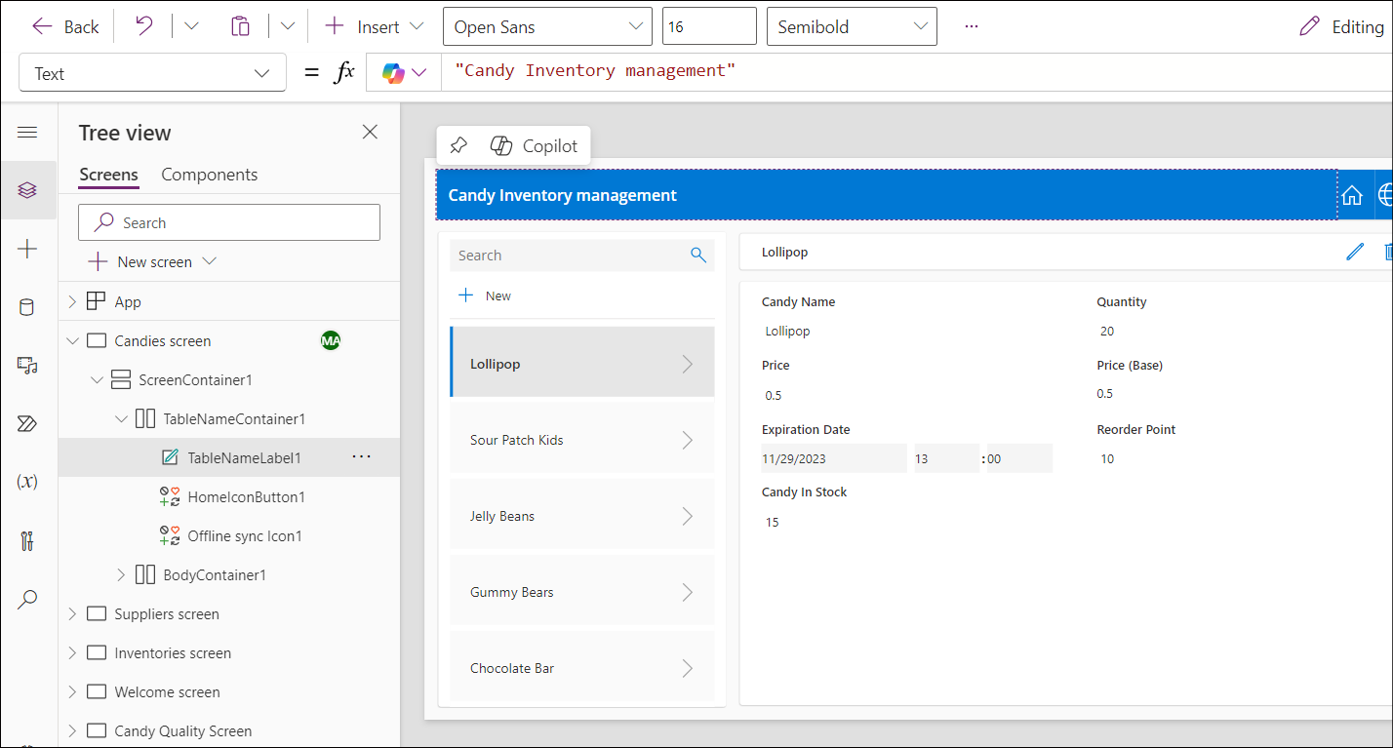

1. Explore the Supplier screen and update as per your requirements.

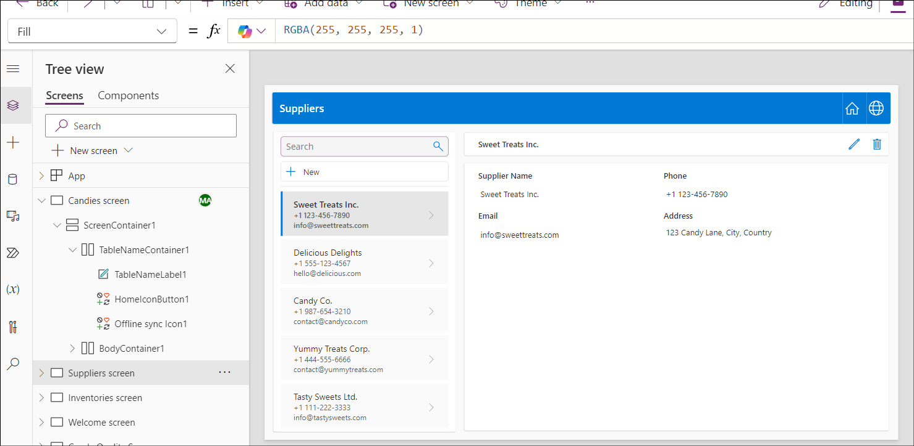

## Task 3: Create candy quality Screen

1. Click on **New Screen** and select **Blank** template.

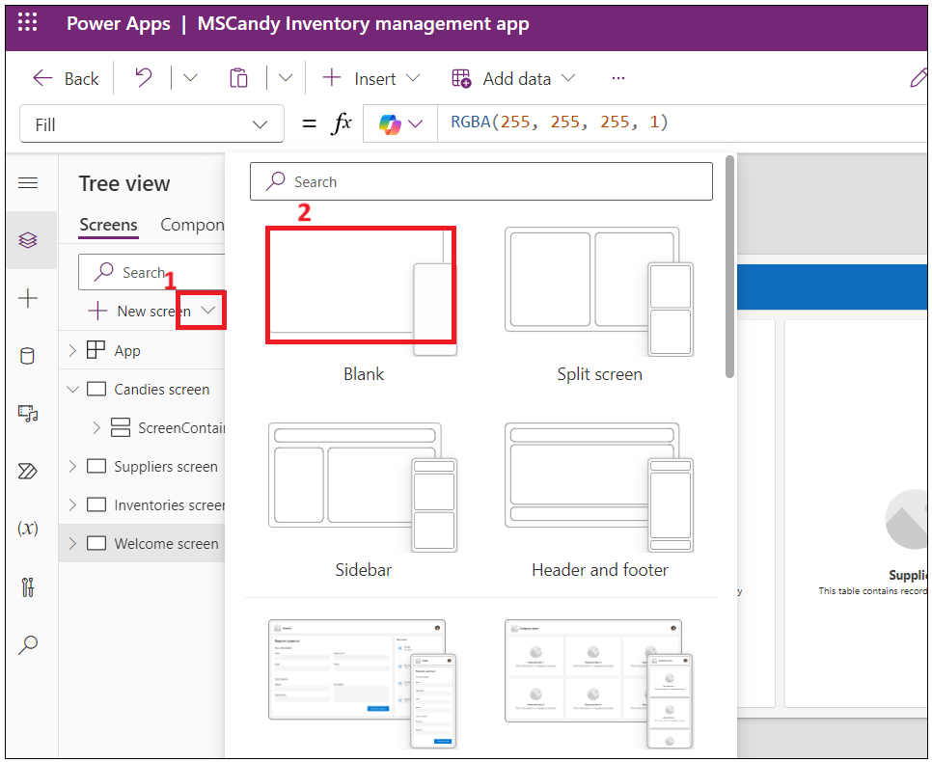

1. Select the new screen and right click -> **rename**

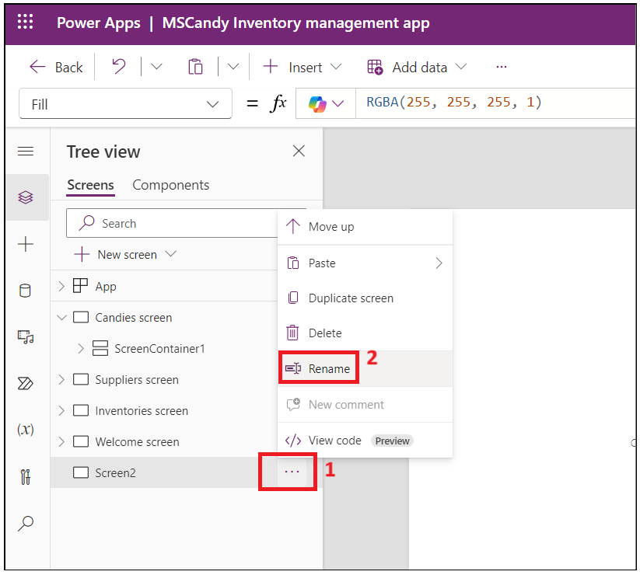

1. Name the screen as **Candy quality screen**

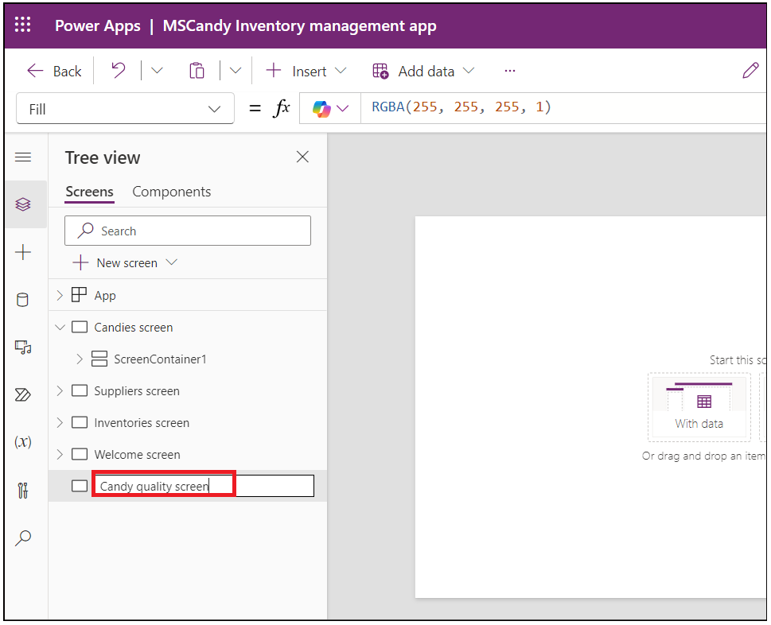

1. Click on Screen area and select **Create a new table(preview)**

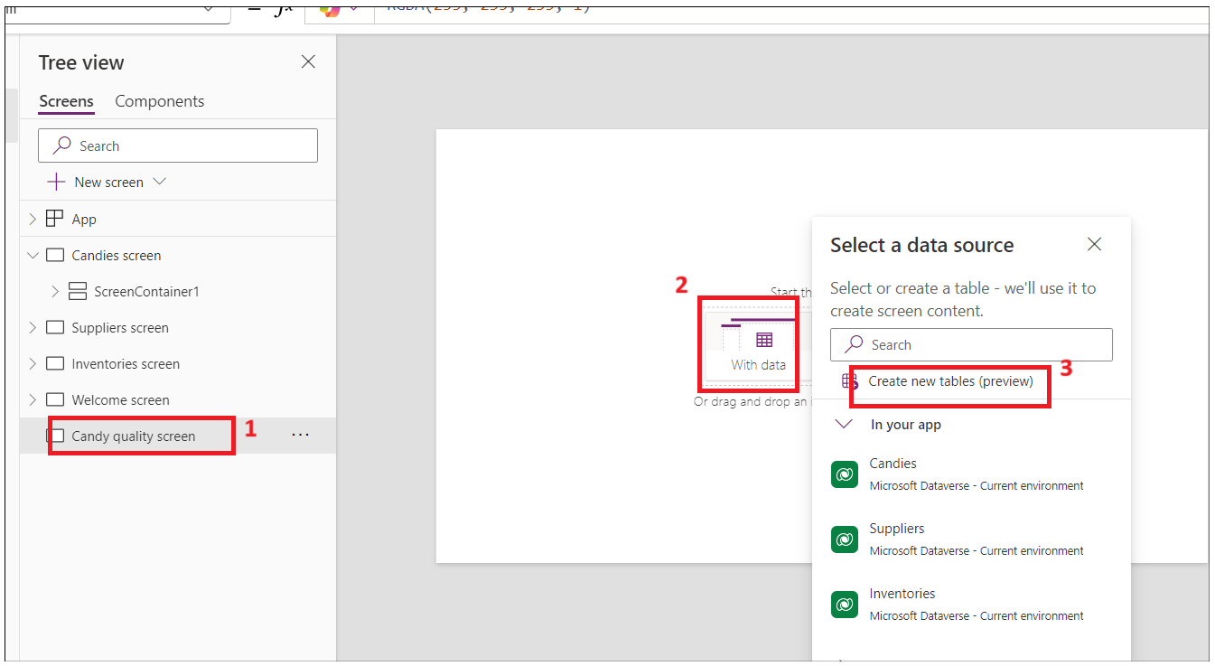

1. Click on **New table -> Add columns and data.**

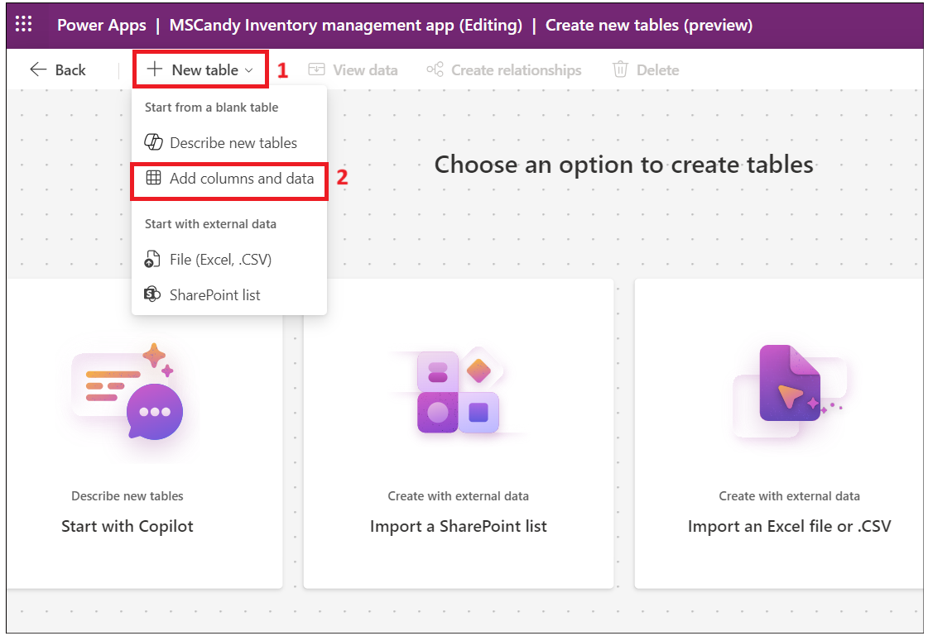

1. Click on **New column-> Edit column.**

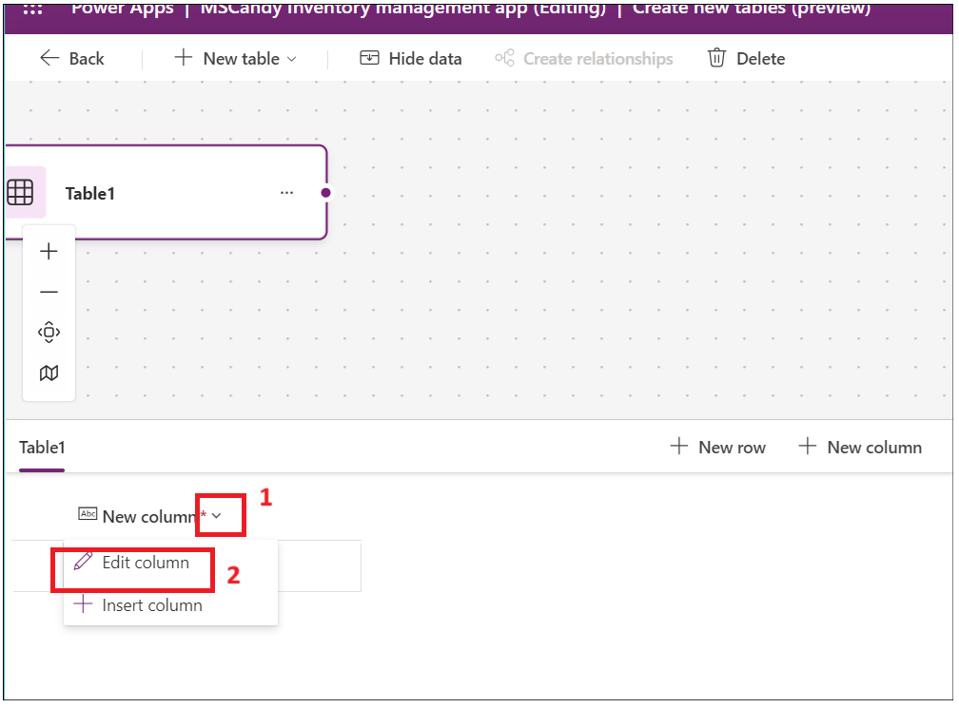

1. Enter the Display name as **Candy ID** and then click on **Update** button.

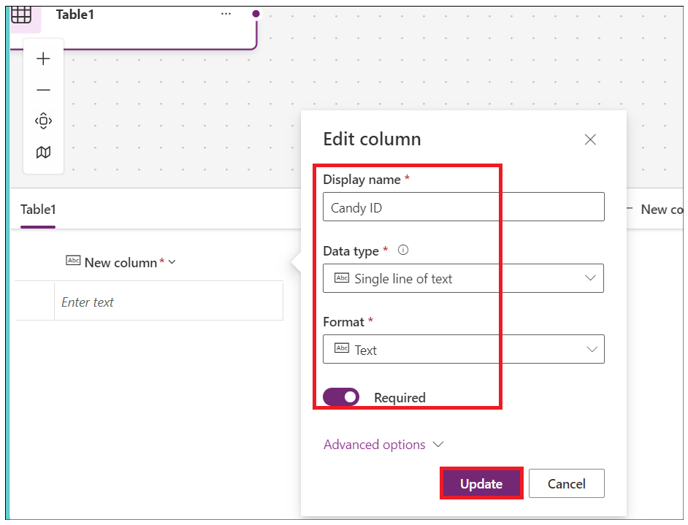

1. Click on New column and enter below details and then click on **Save**.

Display Name: **Candy Name**

Data Type: Choice

Required: Yes.

Choices: add below choices

**Chocolate Bar**

**Gummy Bears**

**Jellybeans**

**Lollipop**

**Sour Patch Kids**

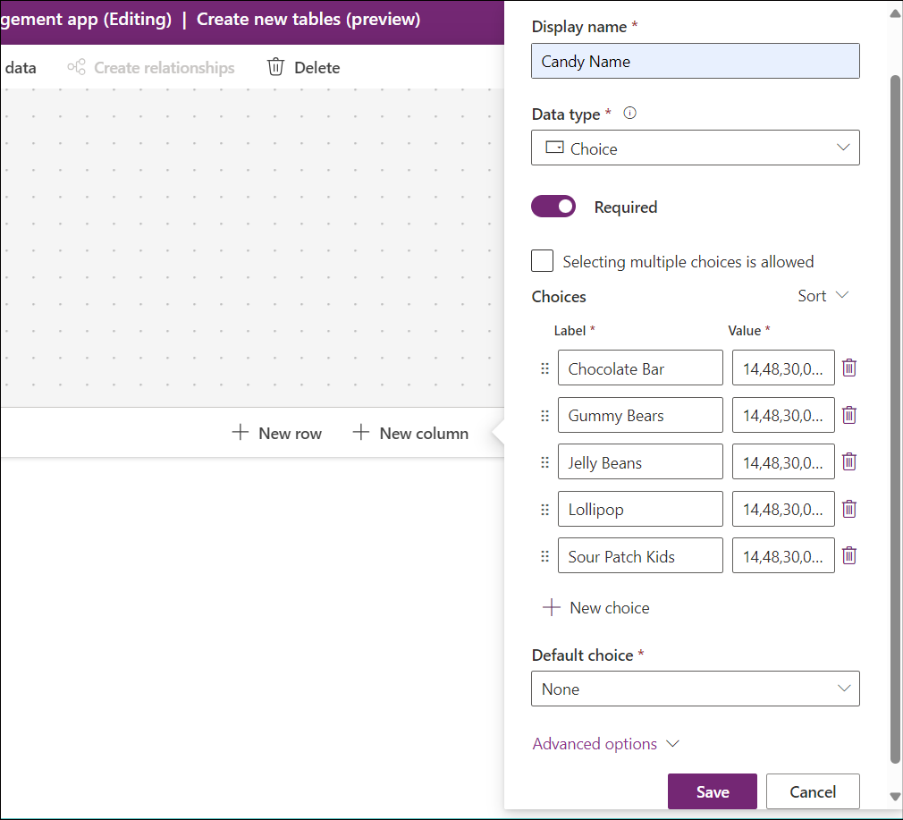

1. Click on New Column and add a column with below details and then click on **Save**.

Display Name: **Candy Quality**

Data type: Choice

Required: Yes

Choice – labels

**Defective**

**Nondefective**

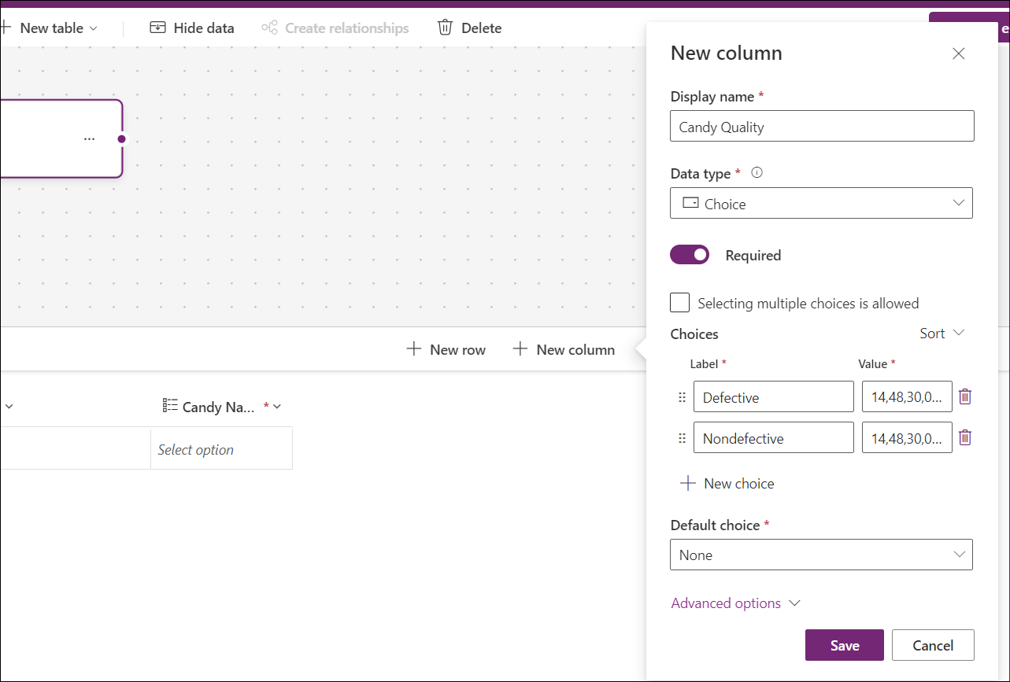

**Note:** You can add more columns as per your app requirements.

1. Edit the table name and update with **Candy Quality**check.

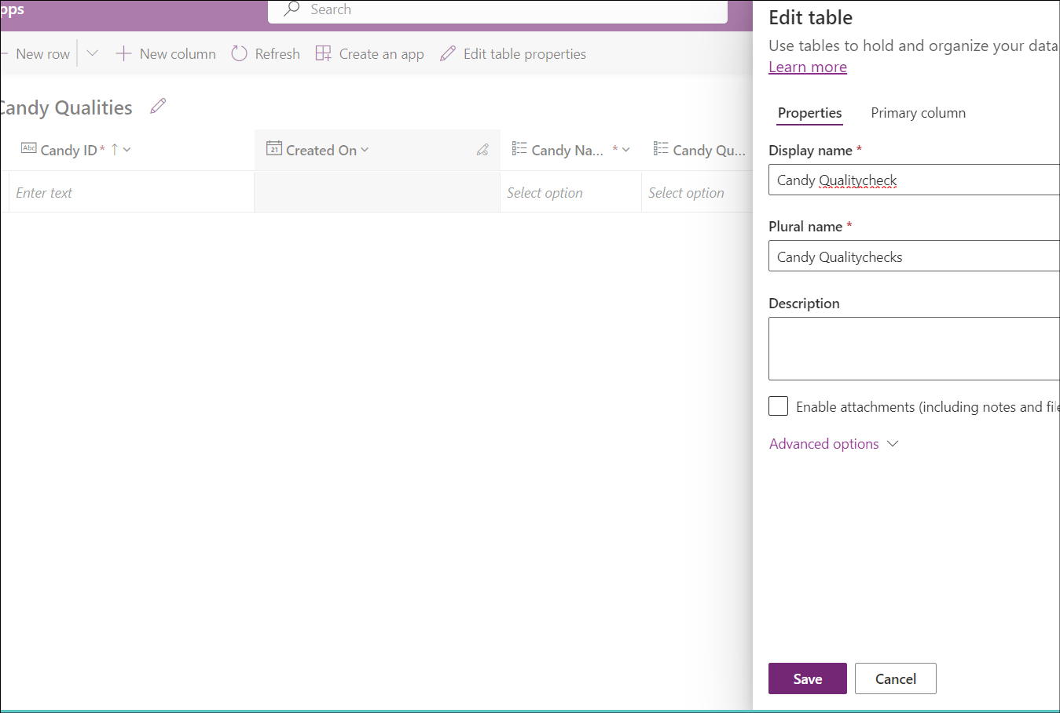

1. Click on **Save and exit -> Save and exit**.

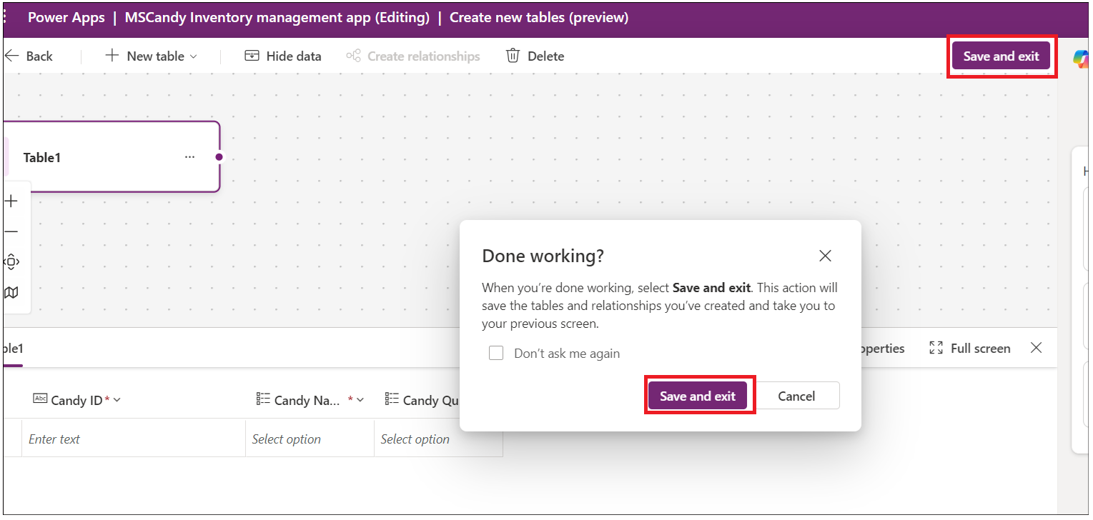

1. You will navigate back to the Power Apps app page. Select the newly added screen and click on Insert and select **Edit form** as shown in below image.

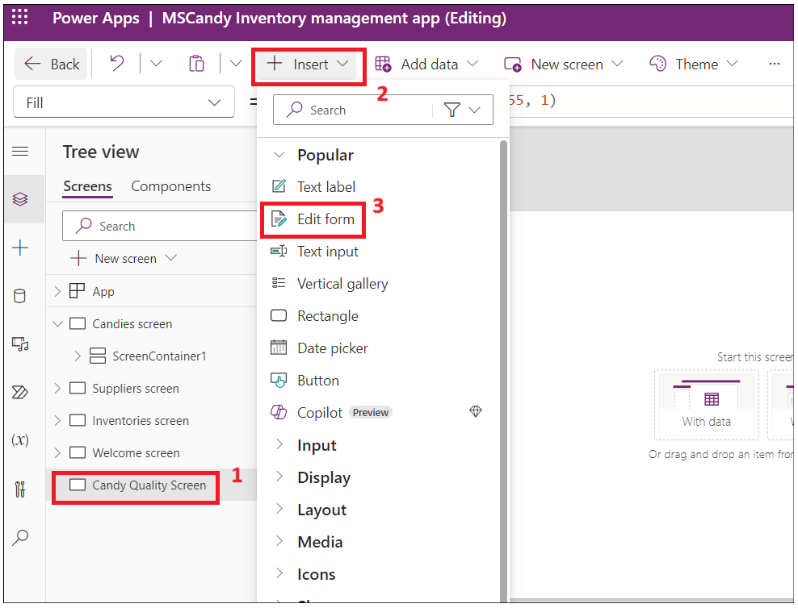

1. Click the container and select the data source table as **Candy Qualities table**.

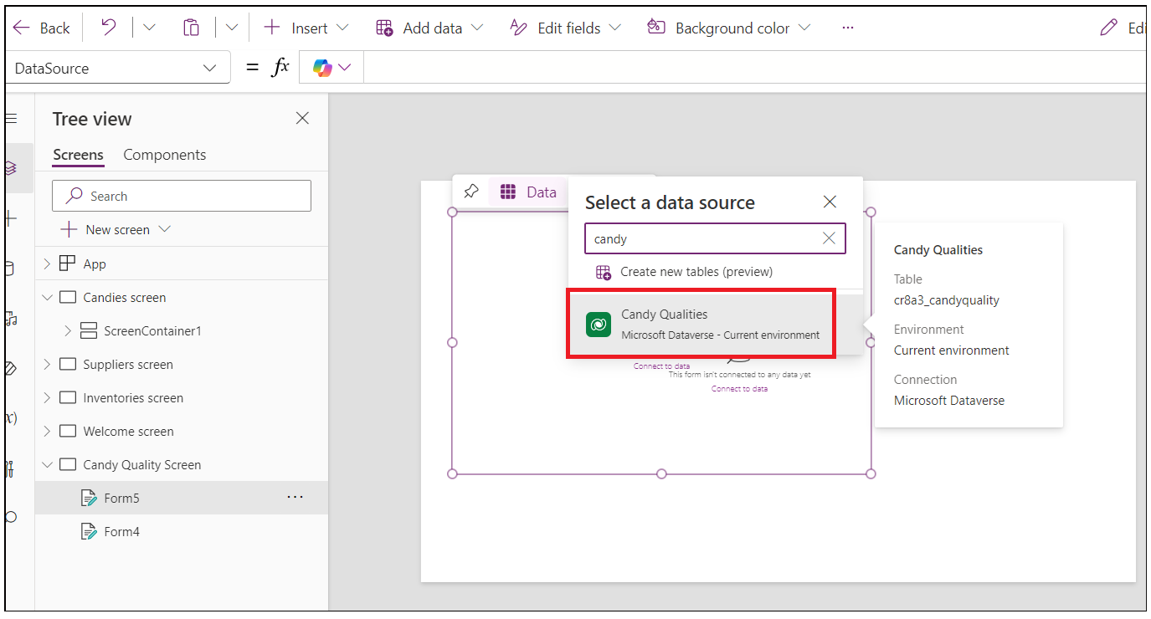

1. You should see the form like below image.

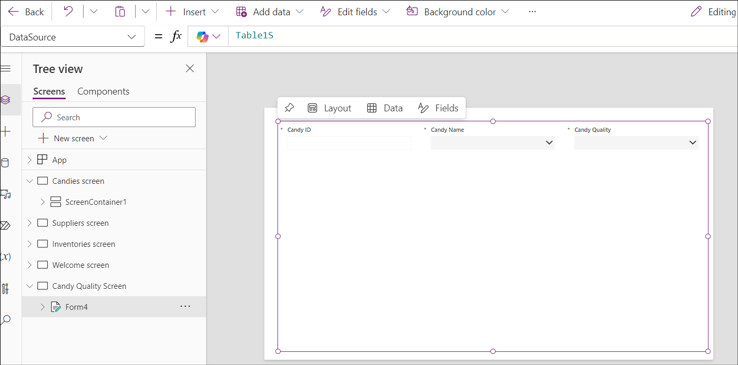

1. Adjust the table to the middle of the page. Click on **Insert-> Text label.**

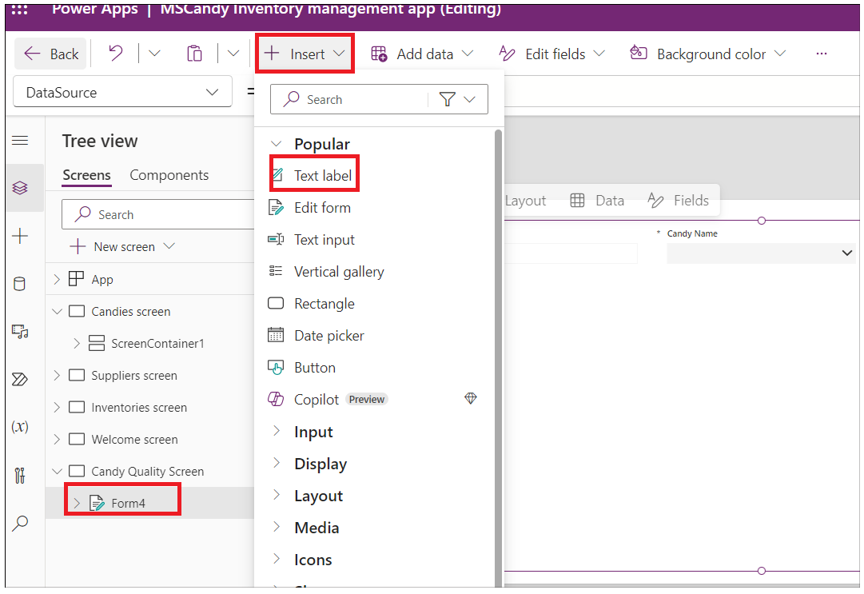

1. Adjust the text label and enter the text as: **Candy Quality check** and update the styles of text.

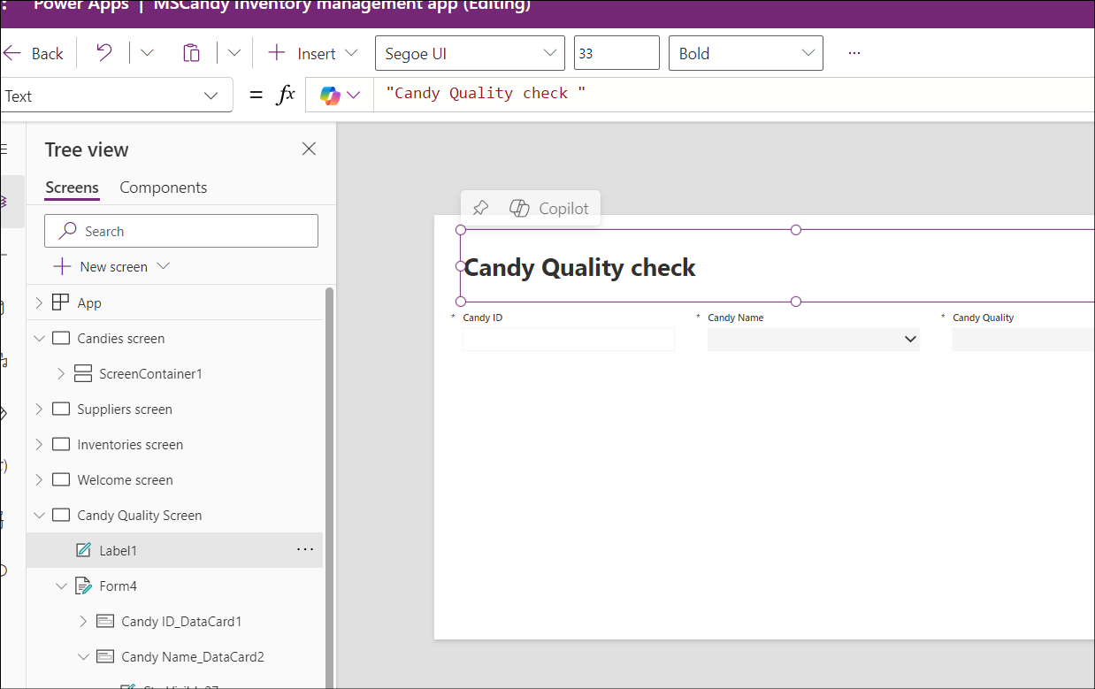 17. Select the **Form**. Click on **Insert** and select **Button**.

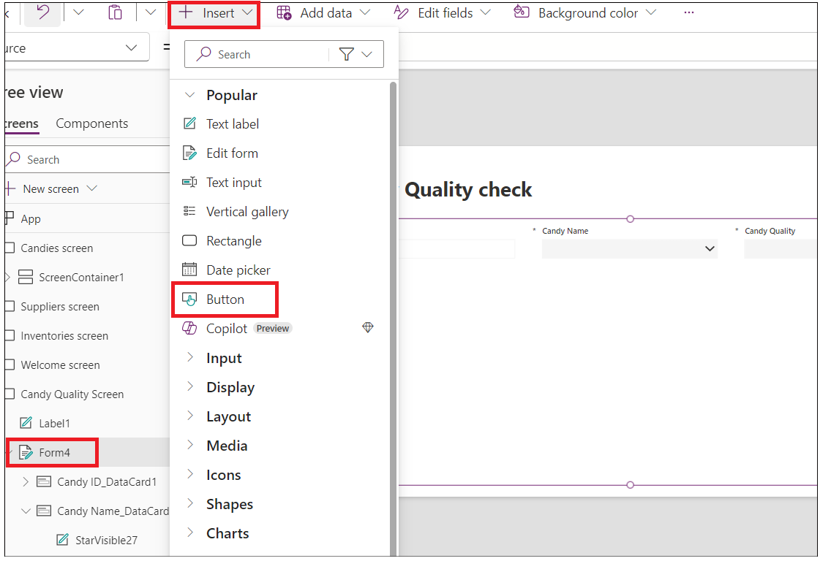

1. Drag the submit button and place it in the middle of the container. Select the button and change the **properties** text to **Submit** as shown in below image.

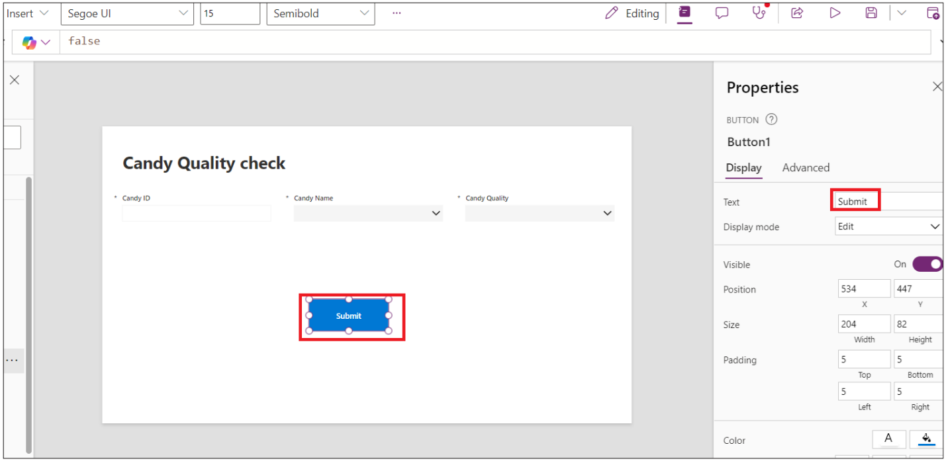

1. Select the **Submit** button and select **OnSelect** function and enter below function.

**Note**: Form4 in the formula should be replaced with your form name

SubmitForm(*Form4*);NewForm(*Form4*)

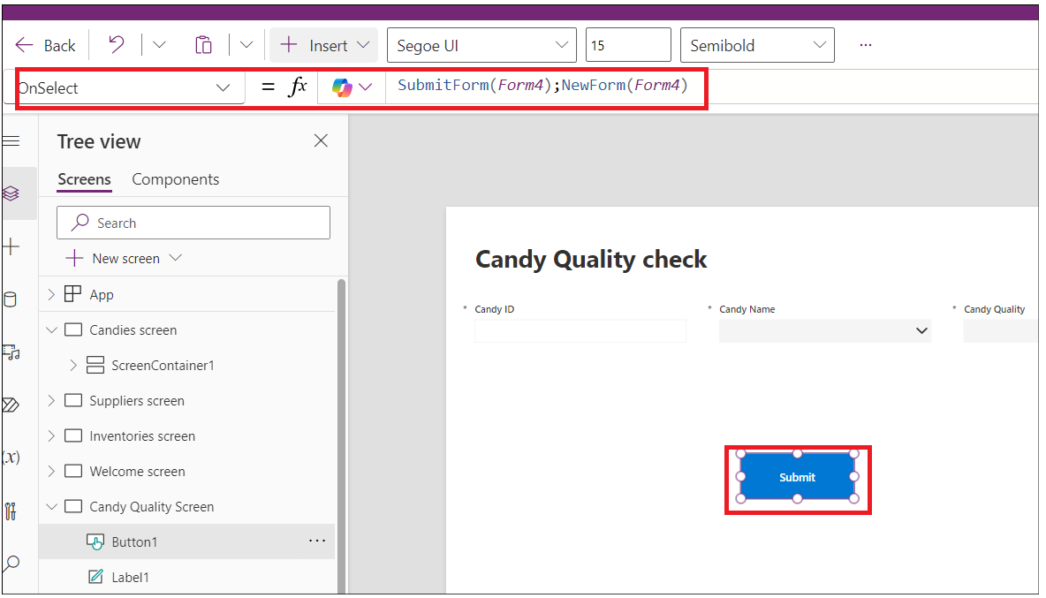

1. Select the container, under properties, select **Default** mode to **New**.

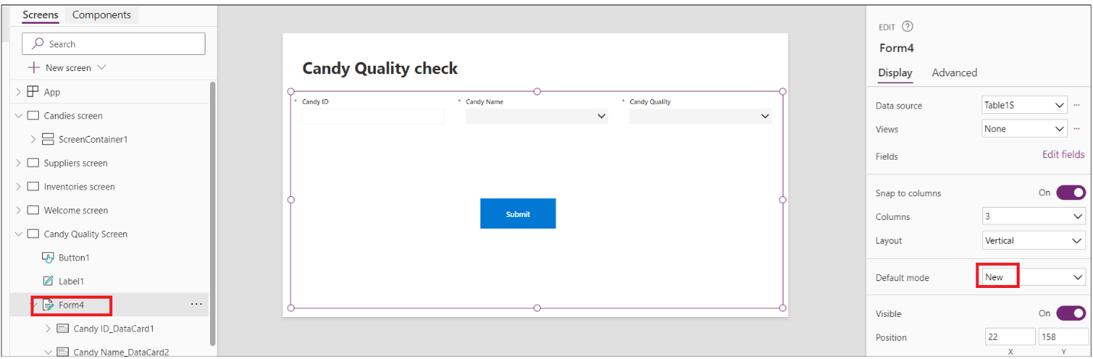

1. Click on **Save** and then click on **Preview app** button as shown in below image.

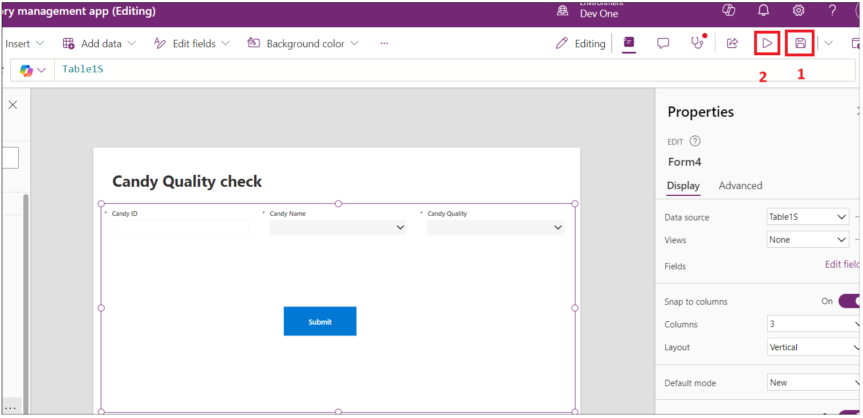

1. Enter Candy details and then click on the Submit button.

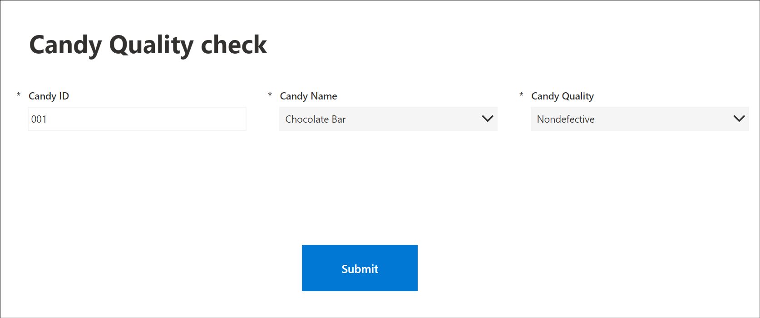

1. Switch back to your Candy quality table in Dataverse environment and you should see the record added above.

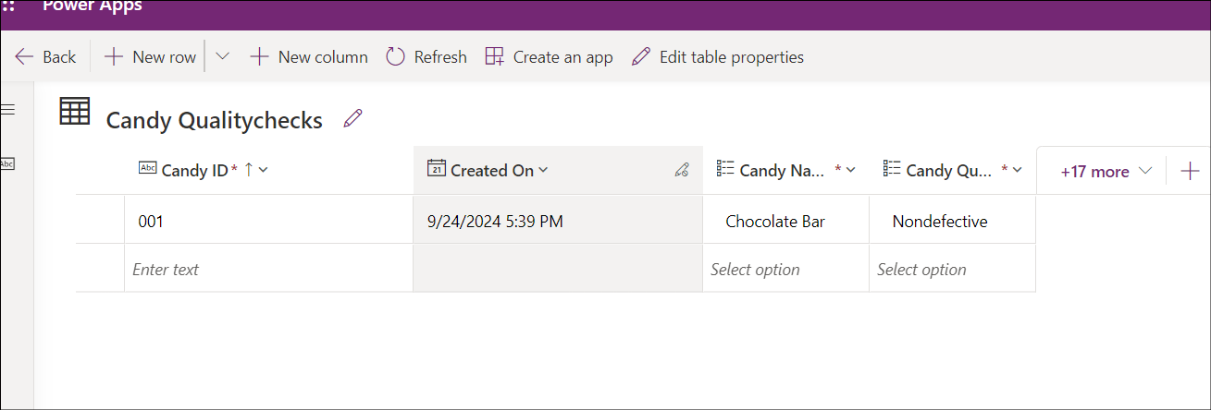

1. Close the preview window.

## Conclusion

After completing this exercise, you will have:

1. Inventory **App with Dashboard and Inventory Table in Dataverse:**

This app allows users to manage and view inventory details through a central dashboard. It features an inventory table stored in Dataverse, where data about inventory items is organized and accessible for tracking, updating, and reporting purposes.

2. **Product Quality Check Screen:**

This screen is designed for evaluating the quality of products. It provides an interface for users to input and review quality check results, ensuring that products meet required standards before they proceed further in the process.

# Exercise 2: Create a Power Automate flow to restock the inventory.

In this exercise, you will create and test an approval request to restock the inventory flow and integrate it with the Inventory management App.

## Task 1: Create a Power platform flow to trigger restock email

1. Switch back to Power Automate tab and click on **My flows** -> **New flow -> Automated cloud flow.**

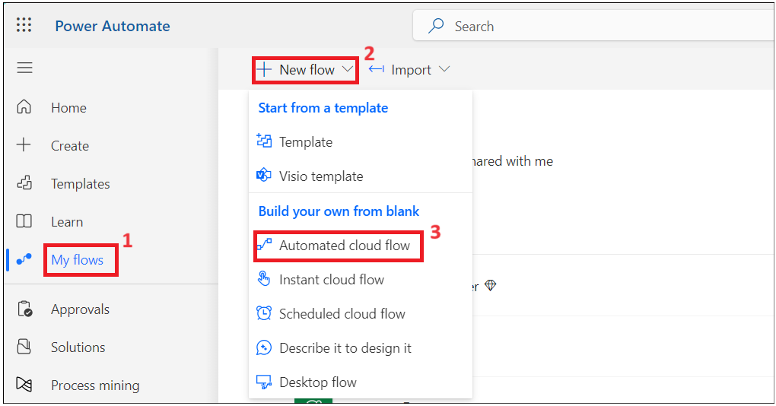

1. Enter the flow name as: **Candy Restock Flow**. Search for **When a row** is and select Dataverse’s **When a row is added or modified** action and then click on **Create**.

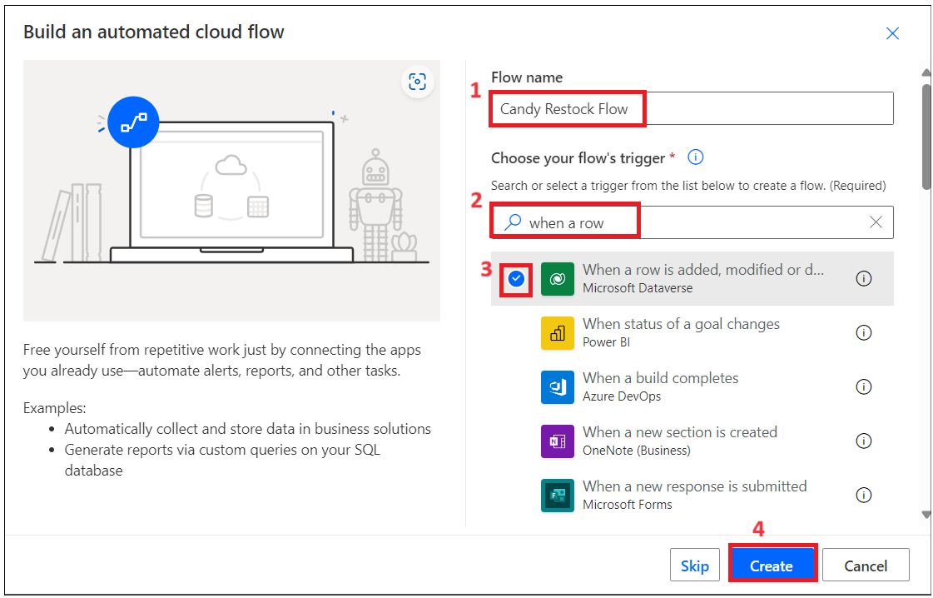

1. Select the action and set the parameters below.

Change Type; **Added or Modified**

Table Name: **Candies**

Scope: **Organization**

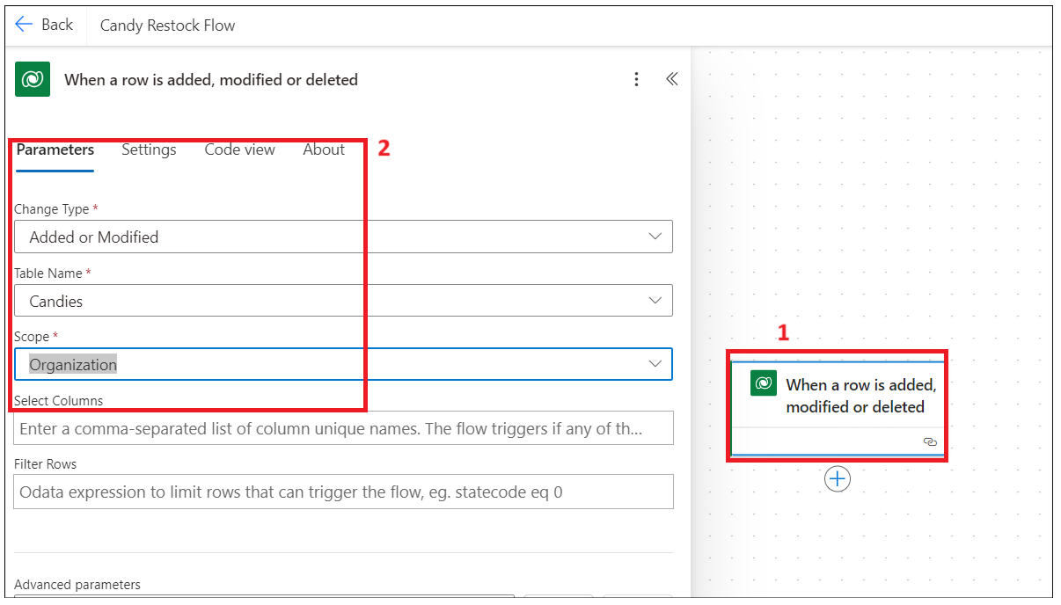

1. Add an action afteran action **“when a row is added, modified or deleted”.**

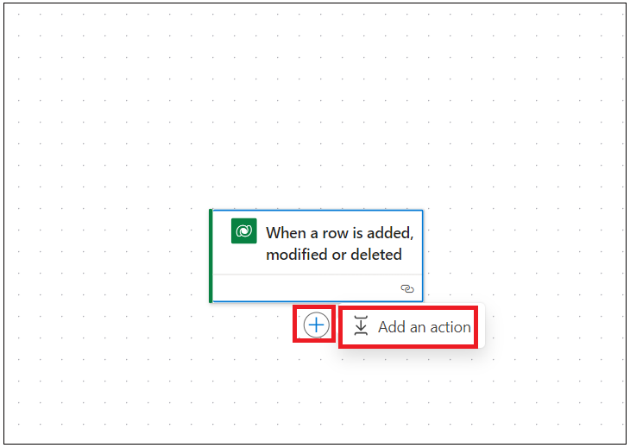

1. Search for **Condition** and select **Control’s Condition** action.

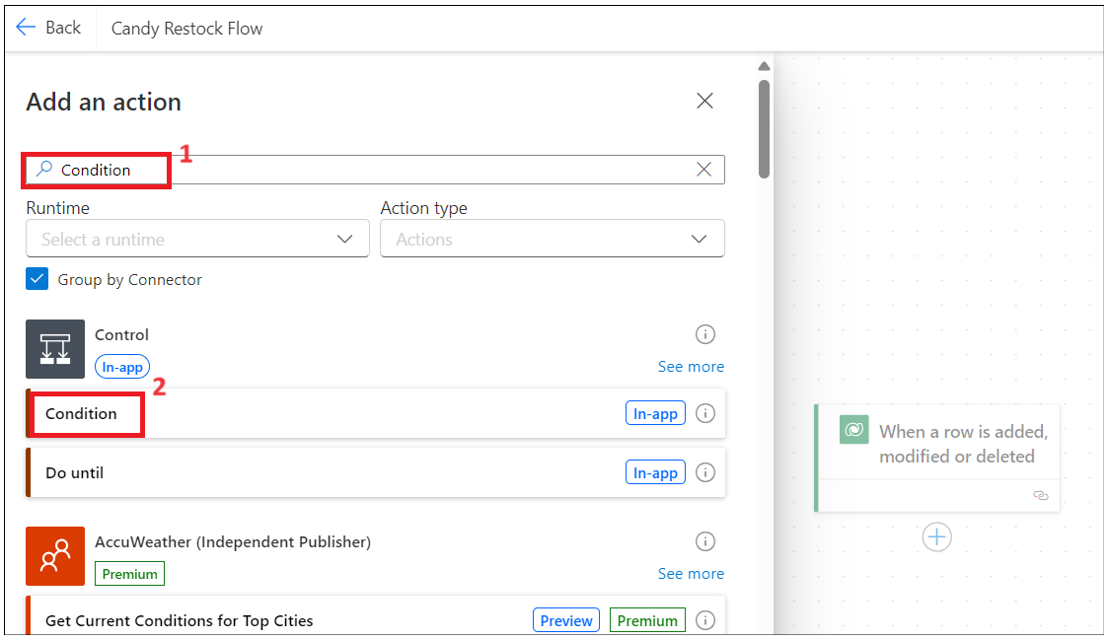

1. Click on Chose value and select choose from previous step dynamic action.

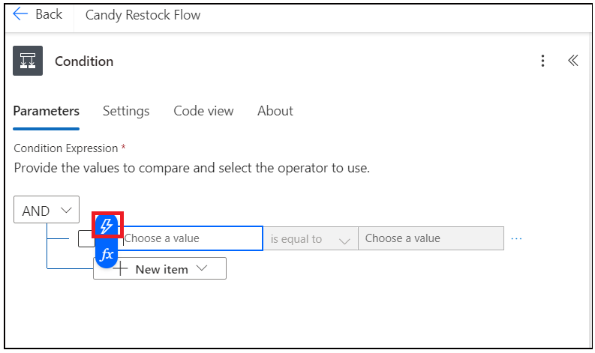

1. Search for **Quantity** column and select it.

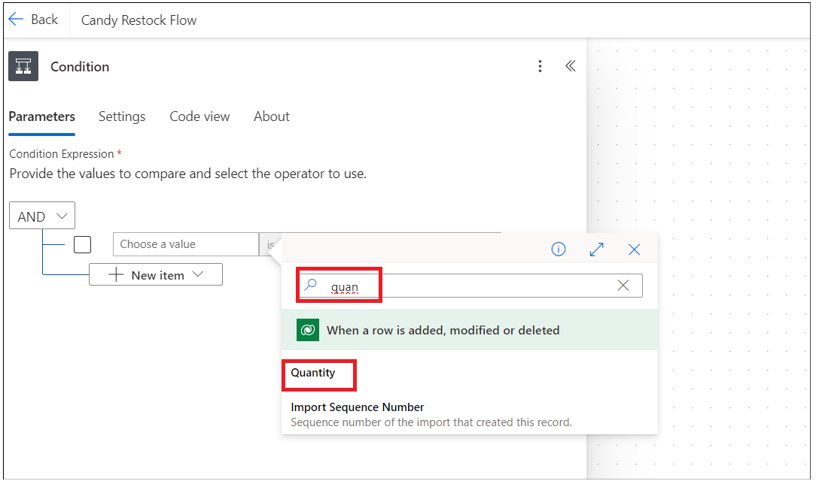

1. Select a condition that **is less than** and click on Enter data from previous action.

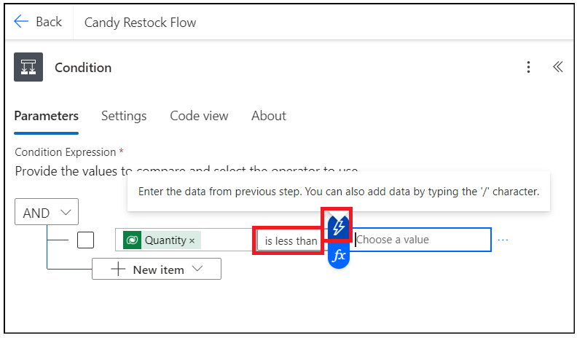

1. Search for the **Reorder points** column and select it.

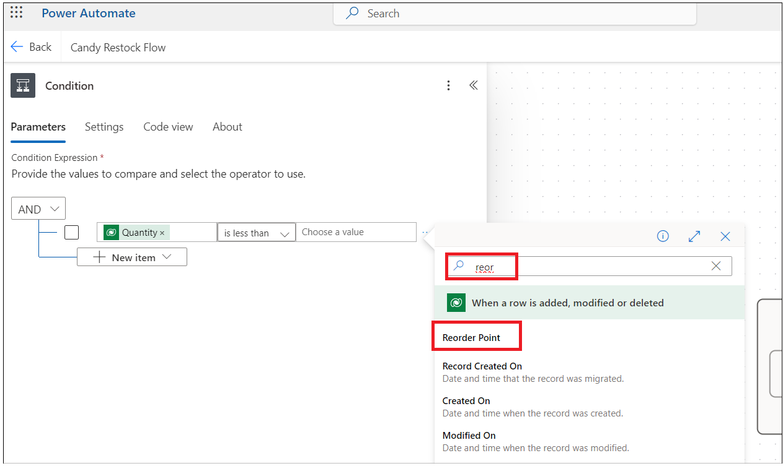

1. **Add an action** under **True** condition.

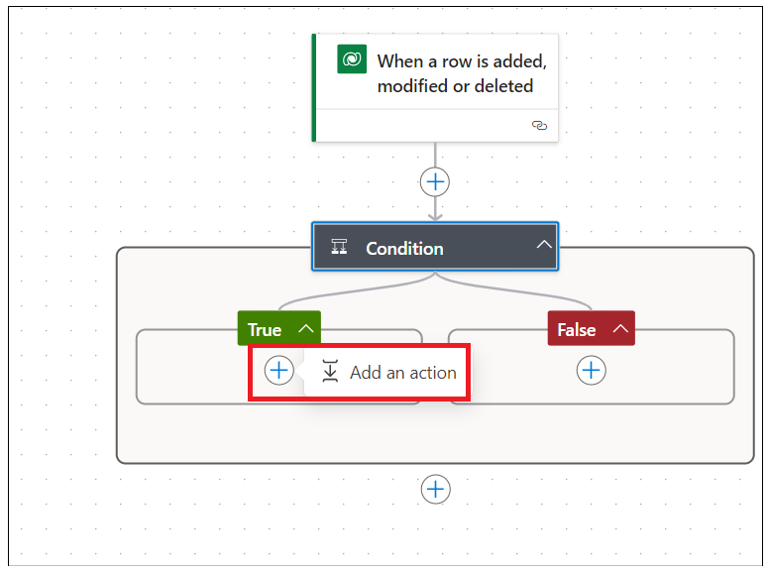

1. Select **Approvals** action.

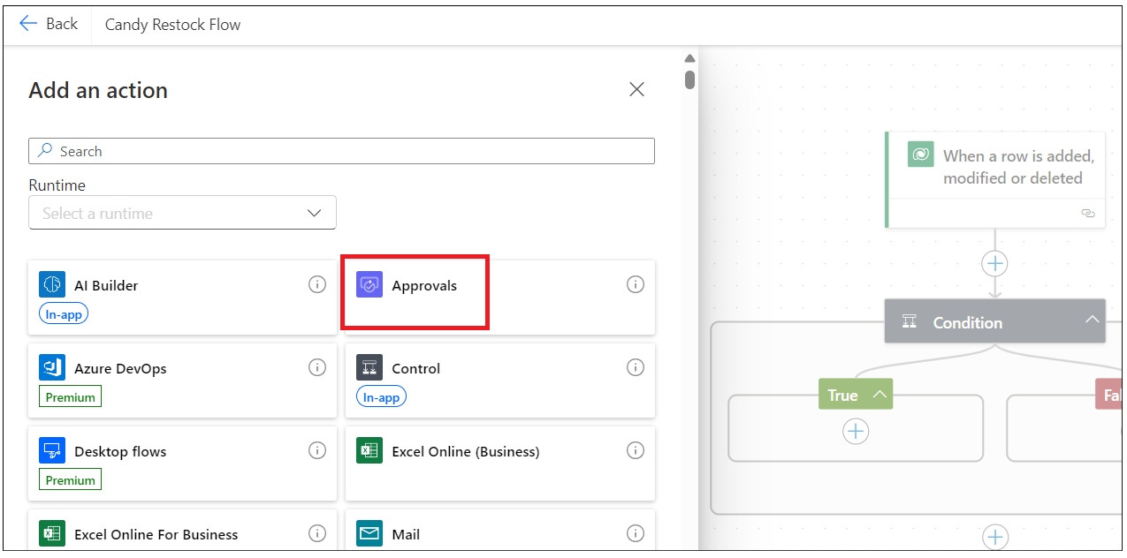

1. Select **Start and wait for an Approvals.**

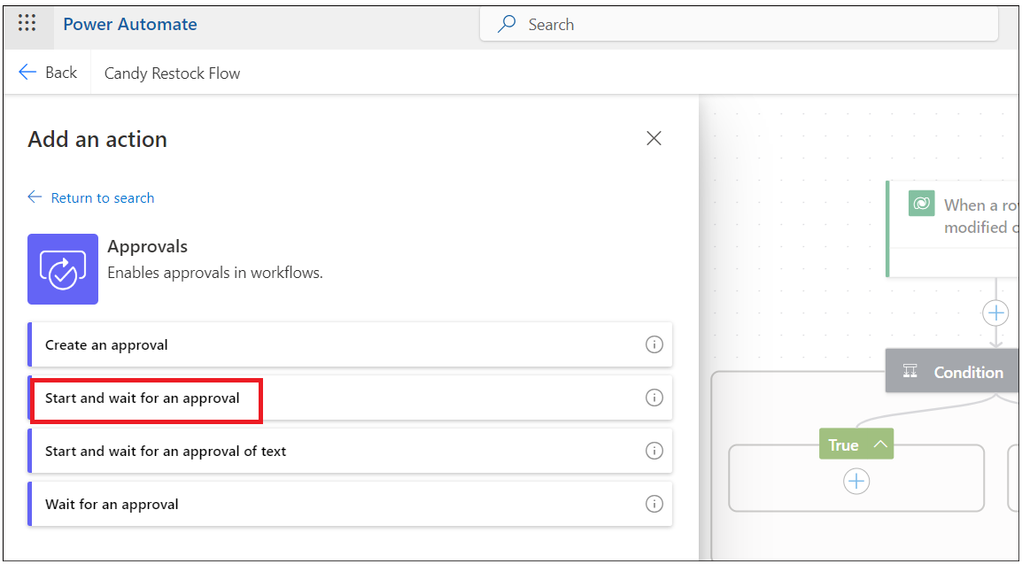

1. Select Approval Type as: **Approve/Reject – First to Respond**. Enter Title as: **Approve to Restock –** and click on Dynamic button to select the data from previous step.

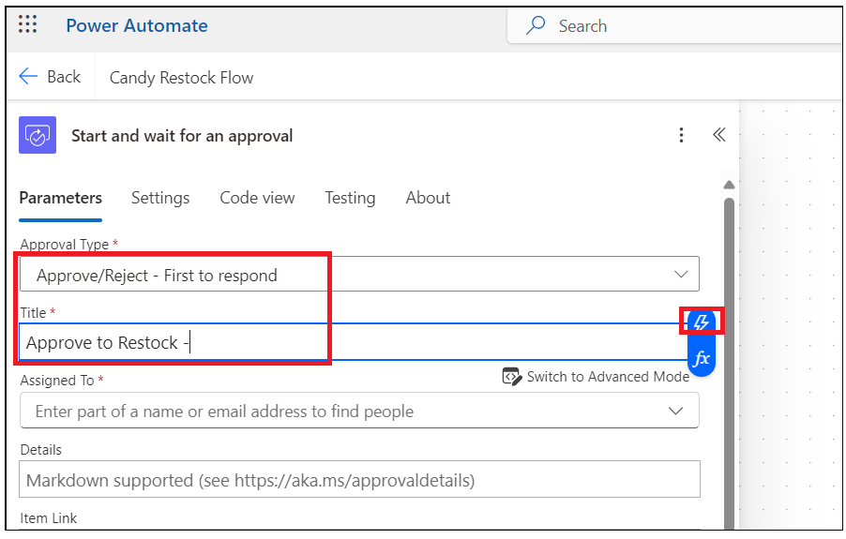

1. Search for **Candy** **Name** and select it.

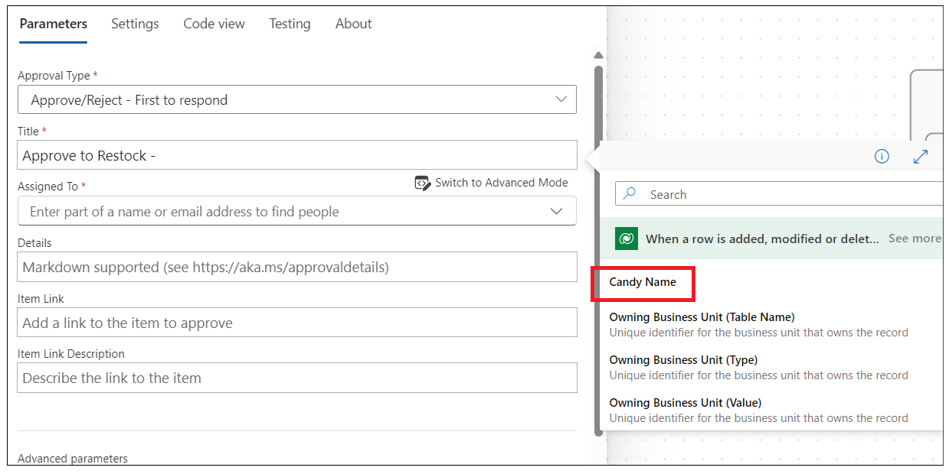

1. Enter below details.

Assigned to: Your work email id.

Details:

Hi Sir,  
  
is out of stock - for customers to place an order. Please approve to restock.  
  
Thanks

Note: You can customize the details section as per your requirements.

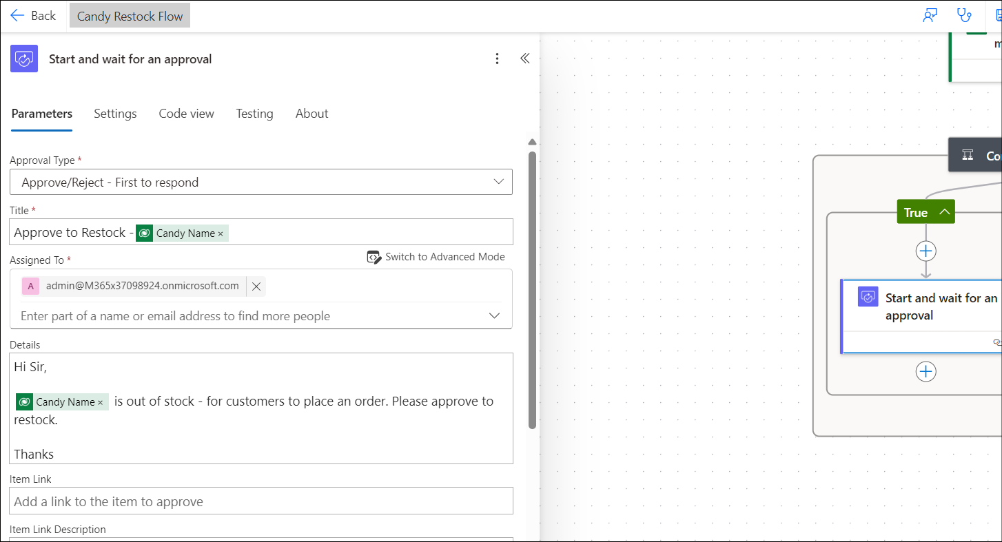

1. **Add an action** after **approval** action.

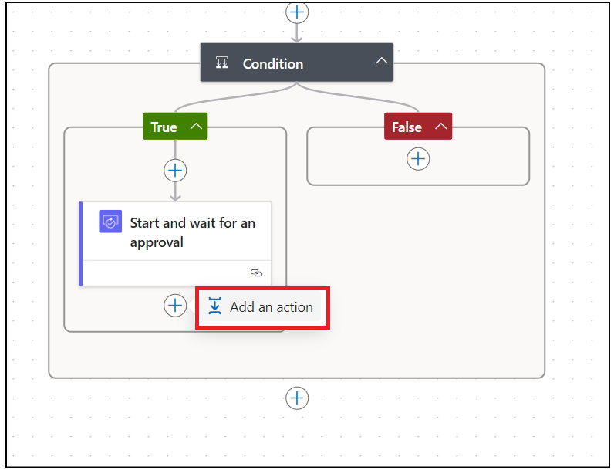

1. Search for **condition** and select **Control – Condition**.

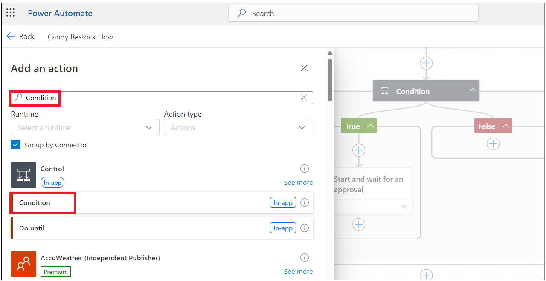

1. Click on Choose value and select **Outcome** from Start and wait for an Approval action.

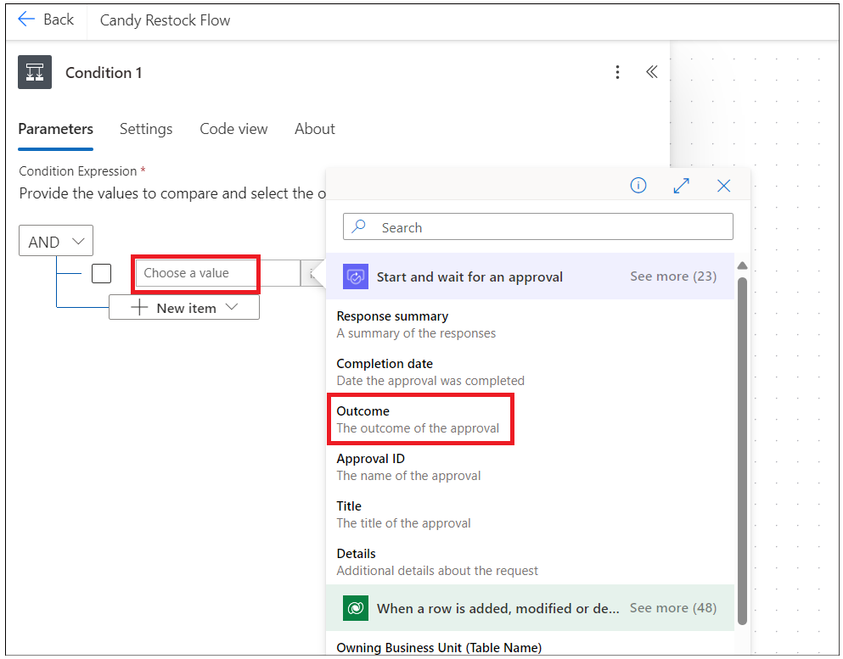

1. Select the condition as **is equal to** and enter the value as **Approve**.

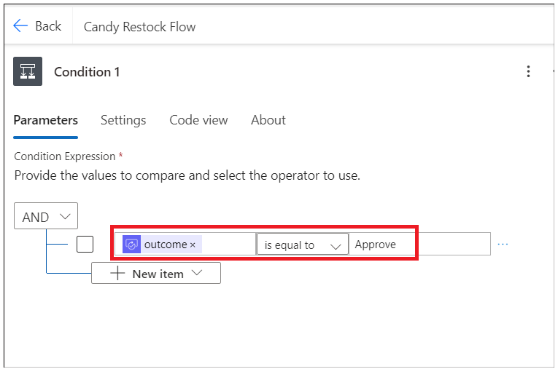

1. Under **True** condition, **add an action**.

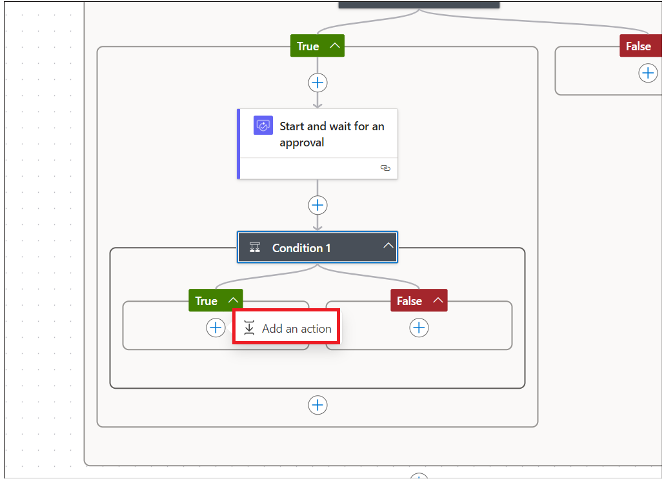

1. Search for **Update Row** and select it from **Microsoft Dataverse** section.

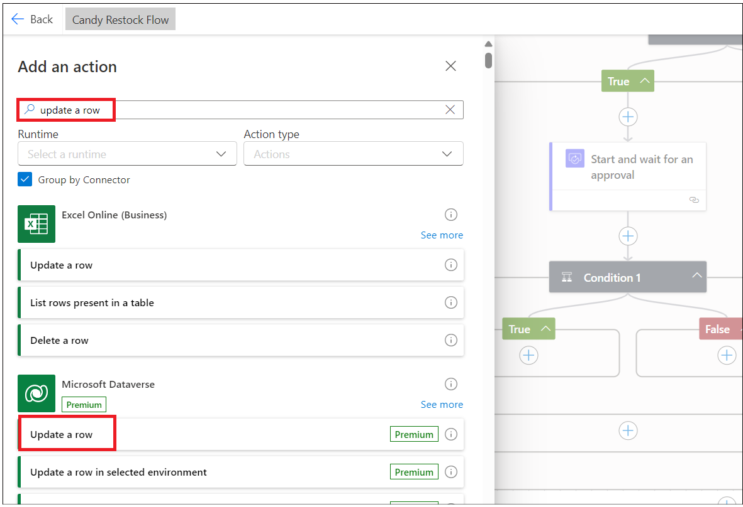

1. Select your **Candy** table and Click on **Row Id** select Dynamic action.

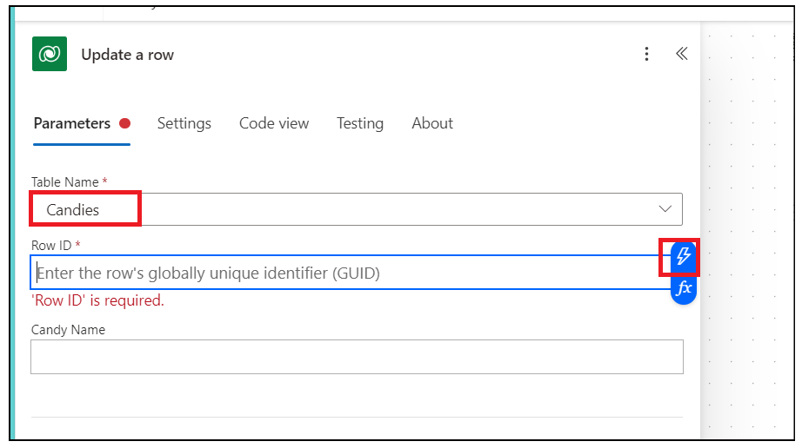

1. Search for a unique identifier column from your table and select it.

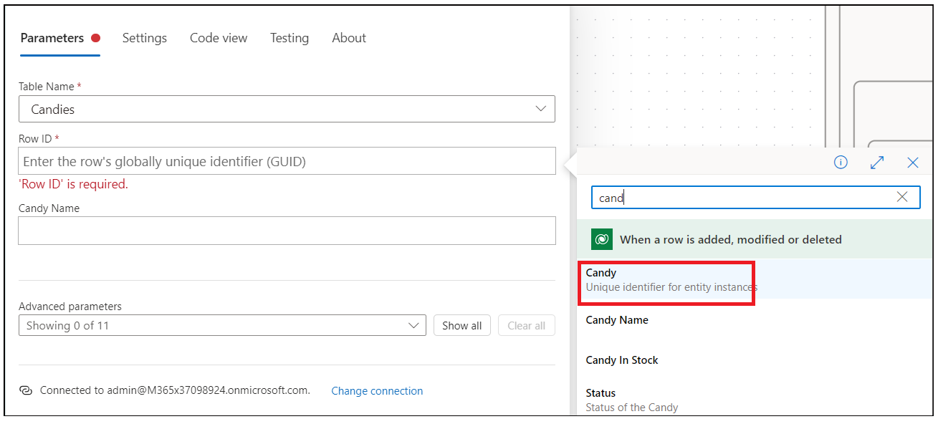

1. Click on **Advanced Parameters** drop down and select **Quantity** column.

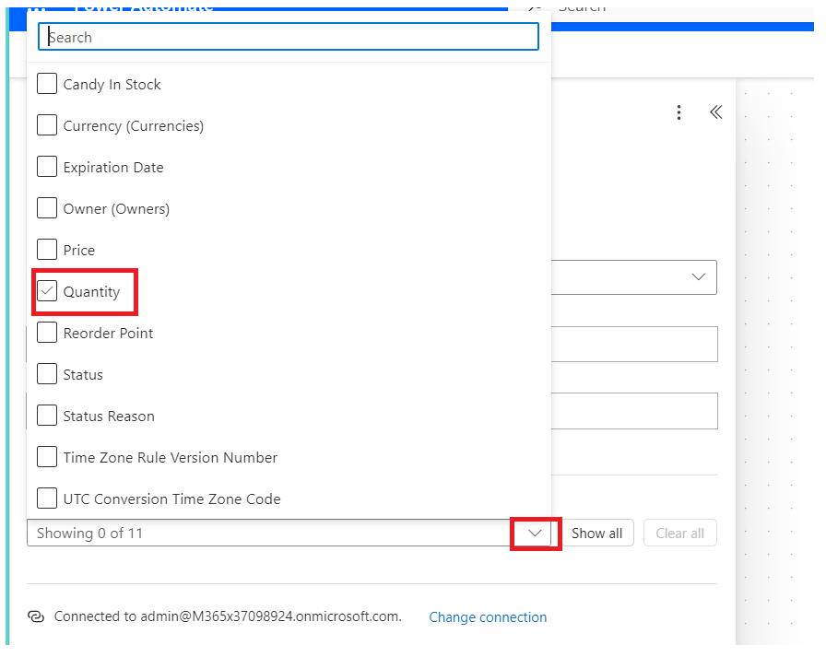

1. Enter the below function (you type in your app) and collapse the action.

**Note:** the below function does not work for you as your column schema name might be different. Go to table-> column and copy schema name

add(triggerBody()?['cr8a3_Quantity'],triggerBody()?['cr8a3_CandyInStock'])

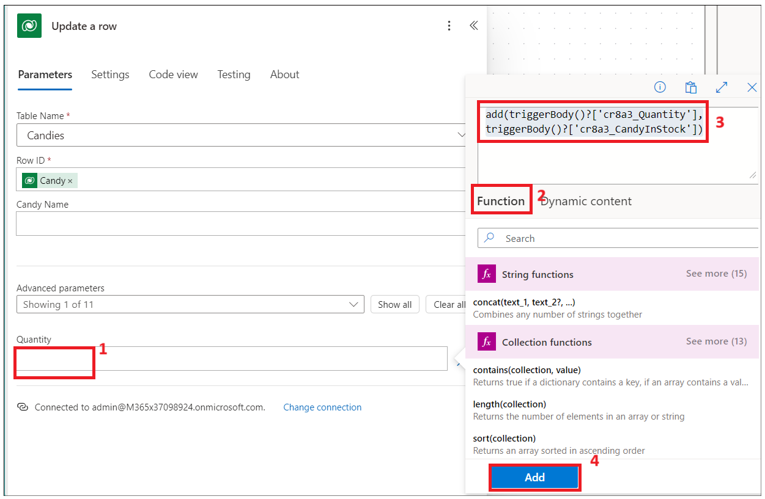

1. Click on **the Save** button to save the Power Automate flow.

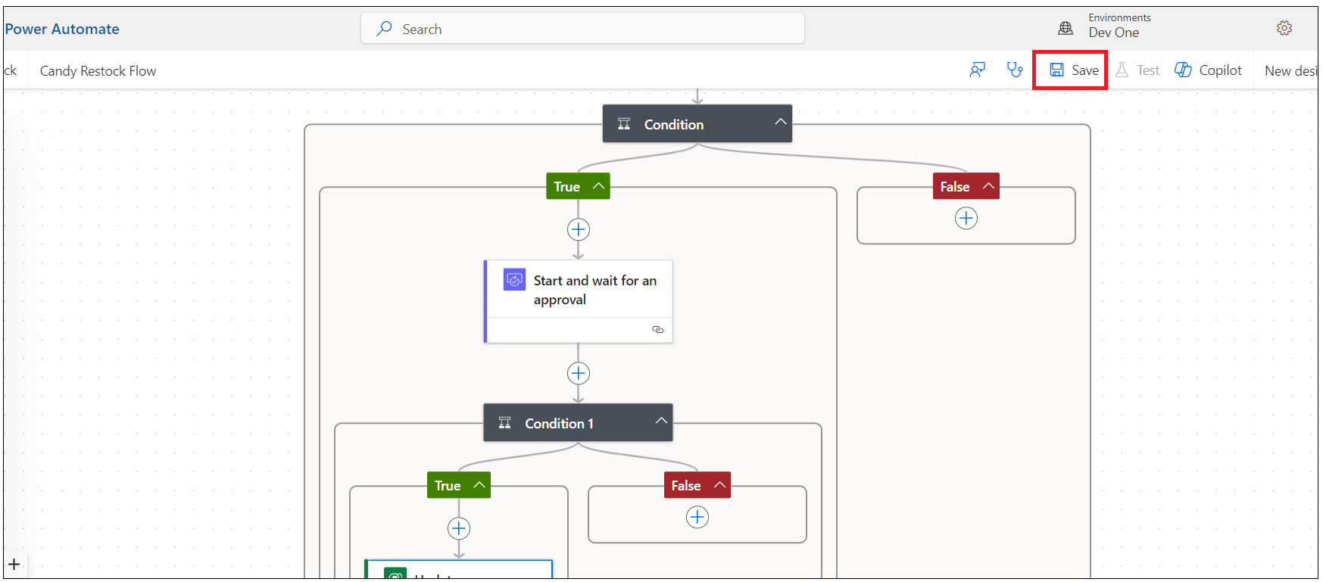

## Task 2: Test the restock flow

1. Switch back to **PowerApps** tab and click on **Candy** screen from left Tree view and select **play**.

Note: You can update the Title of the screen

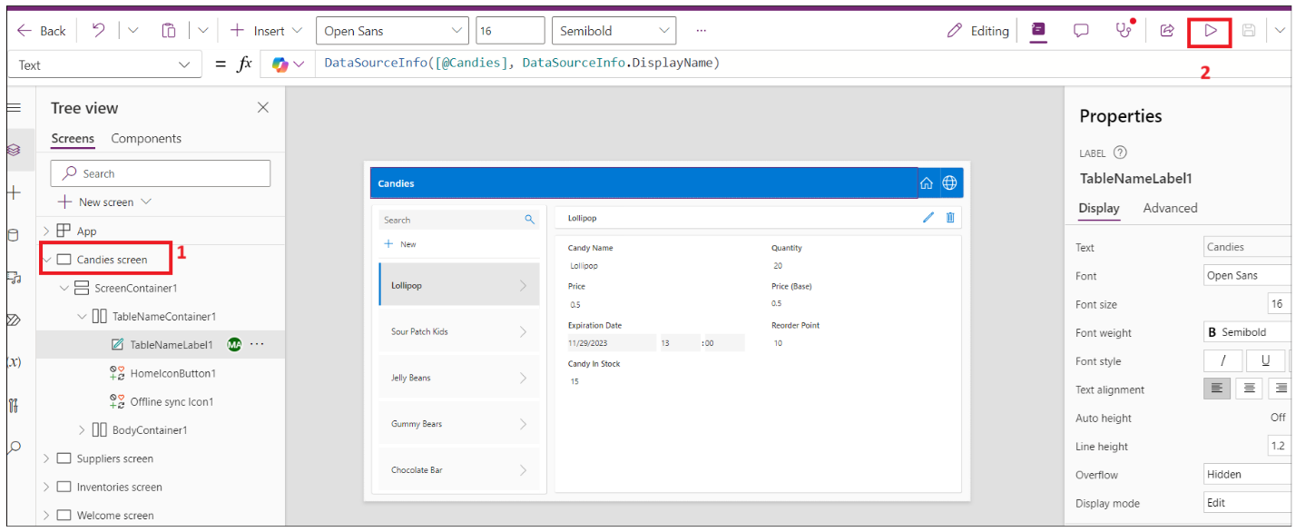

1. Select the Candy and click on **Edit**.

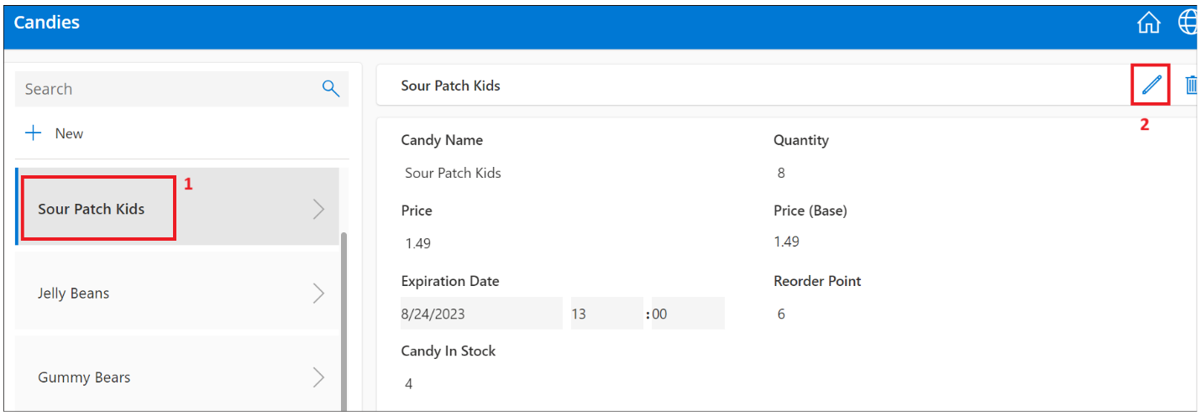

1. Enter the **Quantity** value **less than reorder points** and **commit** changes.

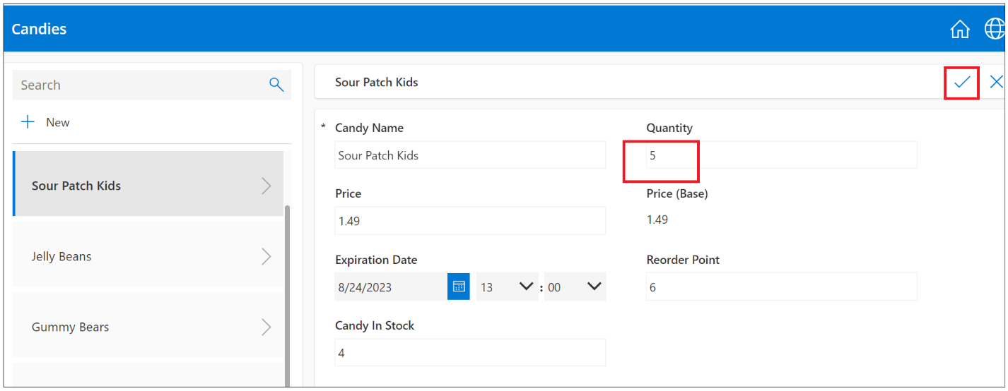

1. Switch back to Power Automate flow tab and click on My flows -> Your flow.

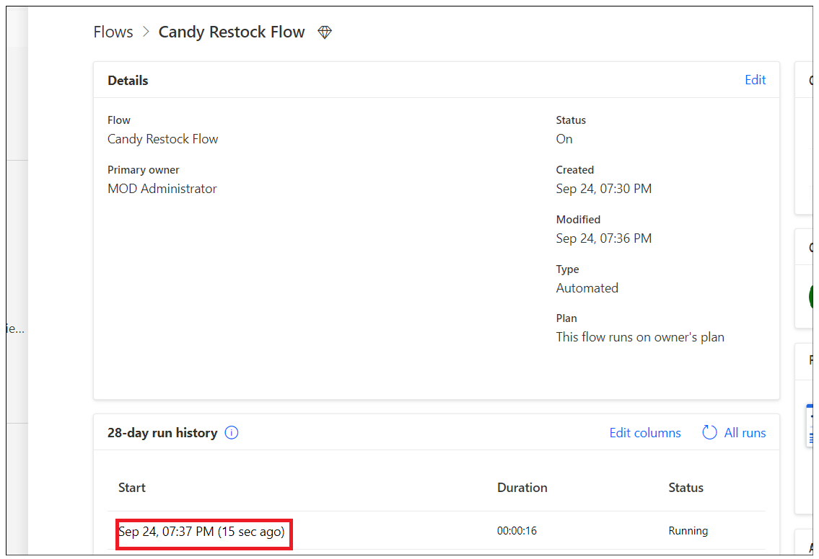

1. Flow is running and is at condition.

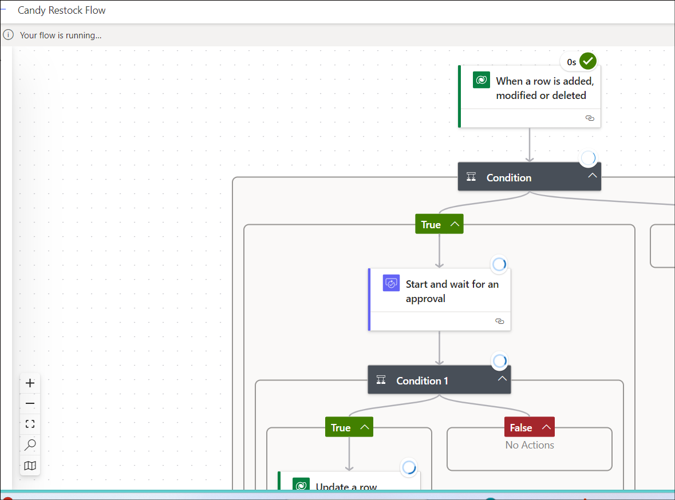

1. Open a new tab and go to https://outlook.com and sign in with your work/admin account. You should have got an email to restock. **Approve** and **submit**.

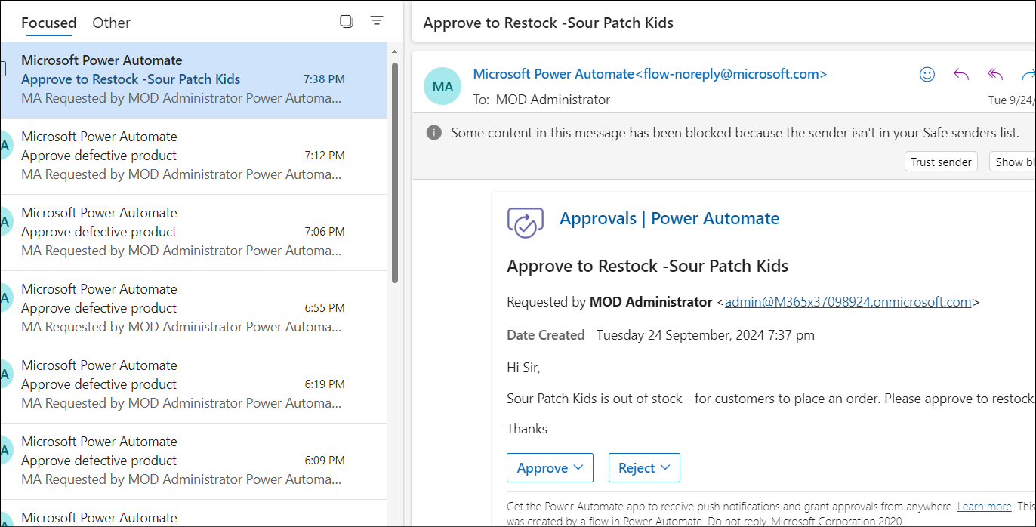

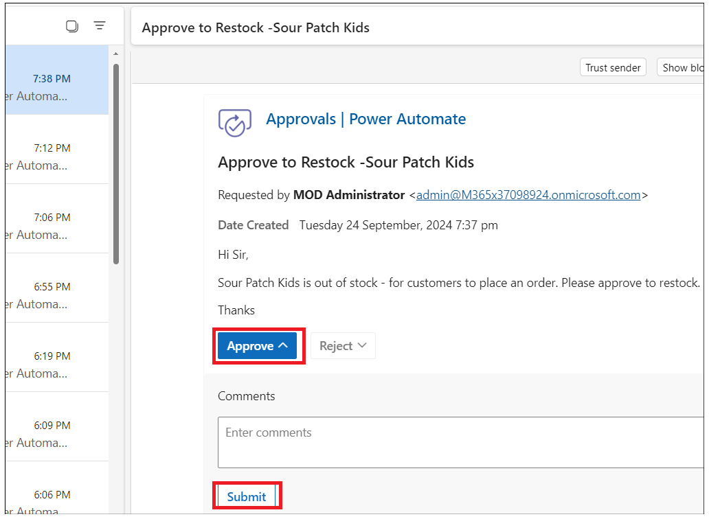

1. The flow is successful now.

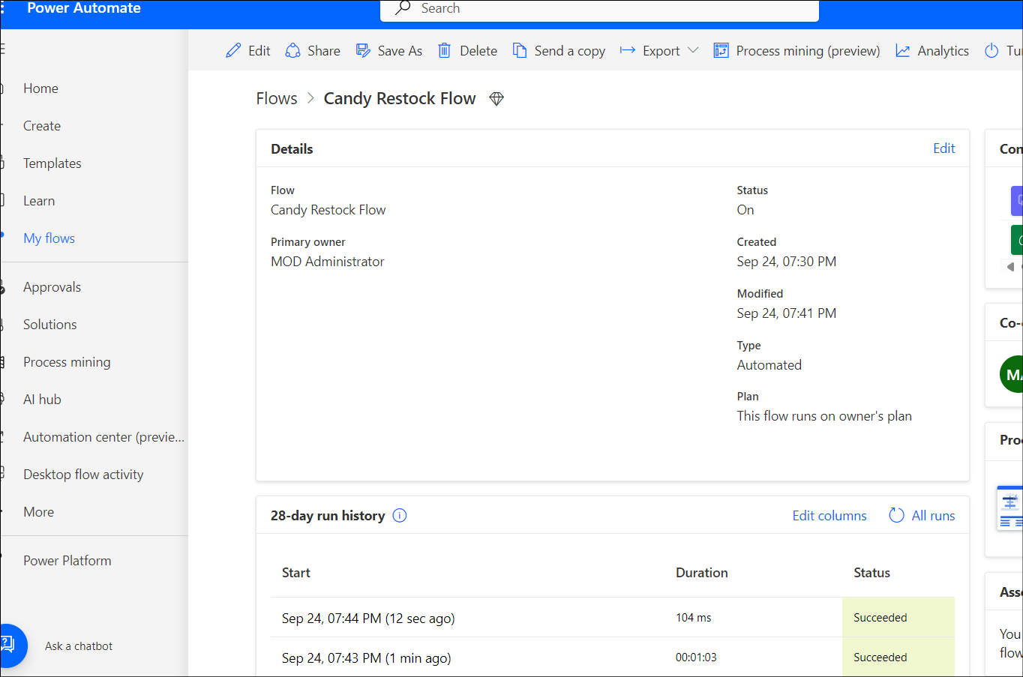

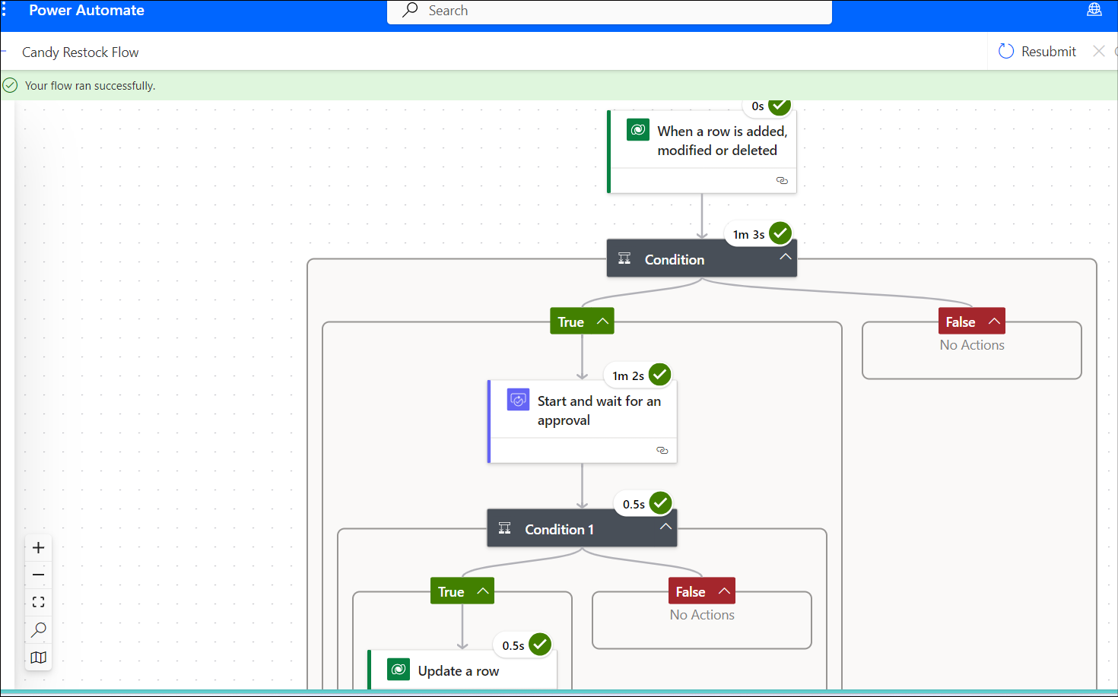

1. Switch back to PowerApps and check the above product quantity. It should have been updated (Candy in stock+ Quantity when its less than reorder point)

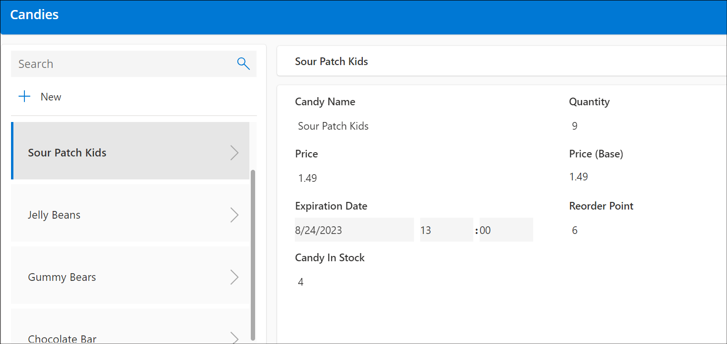

## Conclusion

After completing this exercise, you will have:

1. **Flow to Raise an Approval Ticket for Low Quantity:**

This flow automatically generates an approval ticket when inventory levels fall below a specified threshold. It notifies relevant parties to review and approve actions needed to address the low stock situation.

2. **Flow to Update Quantity Upon Approval for Restocking:**

This flow automatically updates the inventory quantity once approval is granted for restocking.

# Exercise 3: Create a Power Automate flow to notify supplier when item is defective.

In this exercise, you will create Power Automate flow to notify supplier to Approve/Reject when and item is marked as defective/nondefective

## Task 1: Create Power Automate flow to notify the supplier when item is marked defective.

1. Open a new tab in a browser and go to <https://flow.microsoft.com> and sign in with your Work/School/admin tenant.
2. Select the Your Developer environment (**Dev One** environment is used in this lab guide). Click on **My flows** from left navigation menu. Click on **New flow -> Automated cloud flow.**

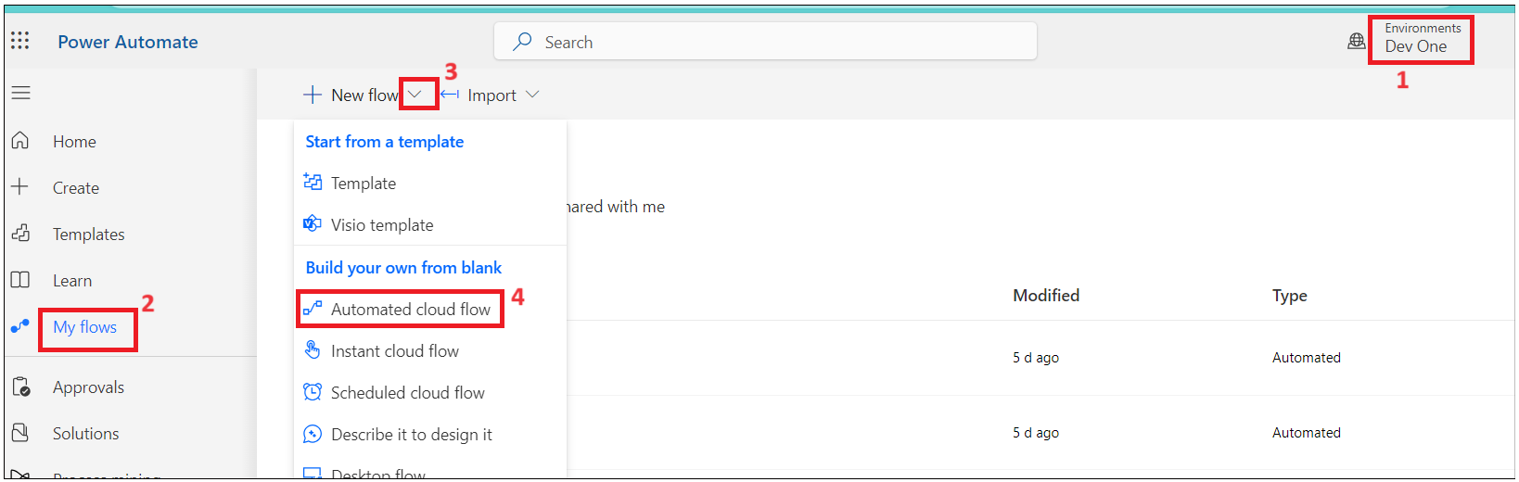

1. Enter the Flow Name: **Notificationsupplier**. Search for **When a row is added, modified or deleted** and select **When a row is added, modified or deleted** and then click on **Create**.

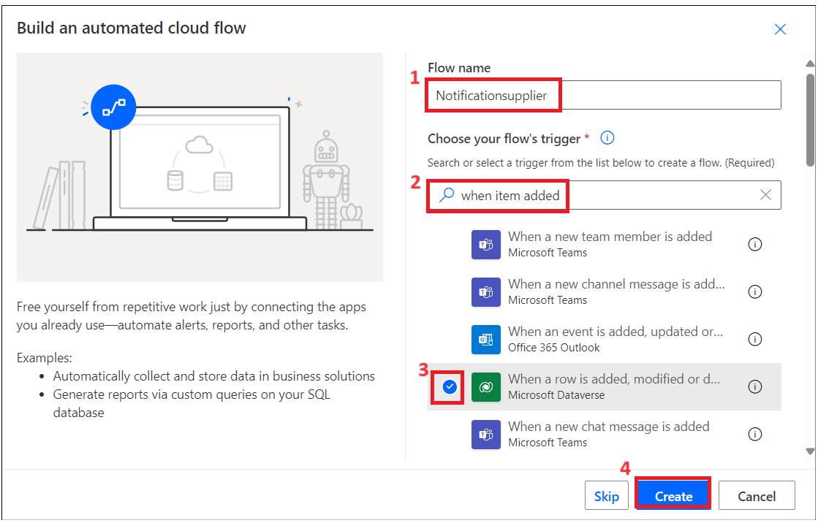4. Select the action and map below parameters.

Change Type: **Added or Modified**

Table name: **candy qualitychecks**

Scope: **Organization**

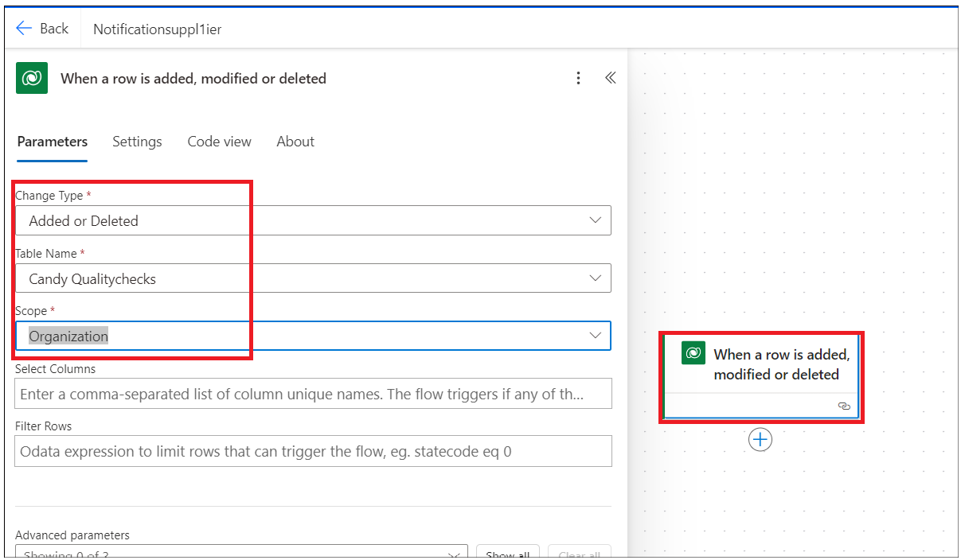

1. Click on + and select **Add an action**.

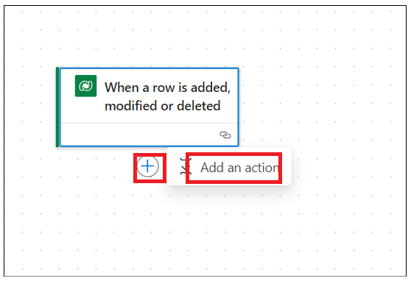

1. Search for **Condition** **and select** Condition control as shown in below image.

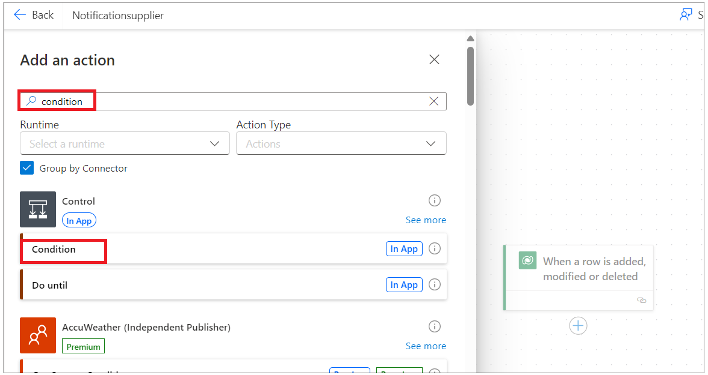

1. Click on chose a value and select choose a **Enter the data from previous step**.

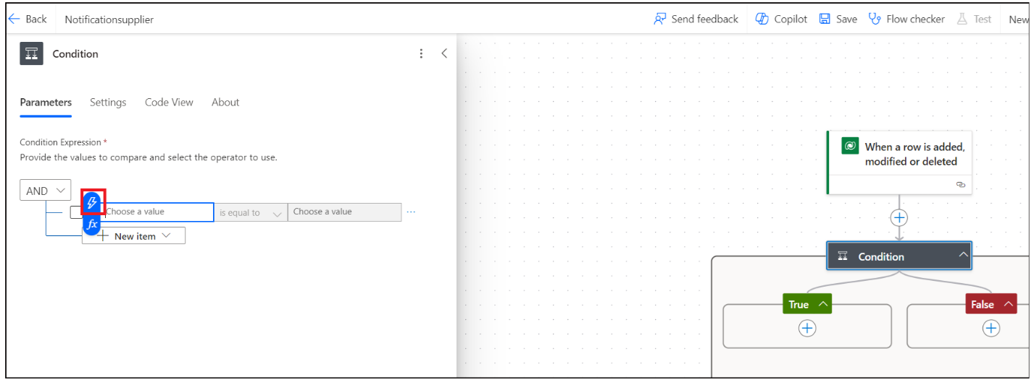

1. Select **Candy** **Quality check** column.

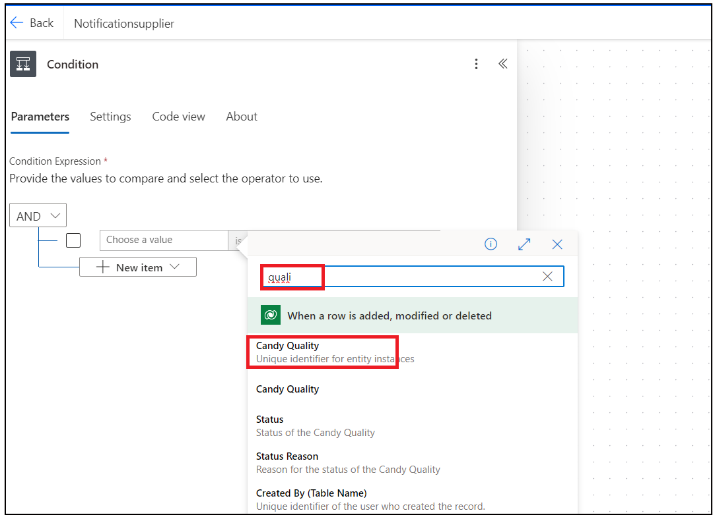

1. Select is equal to and enter the value as **Defective**.

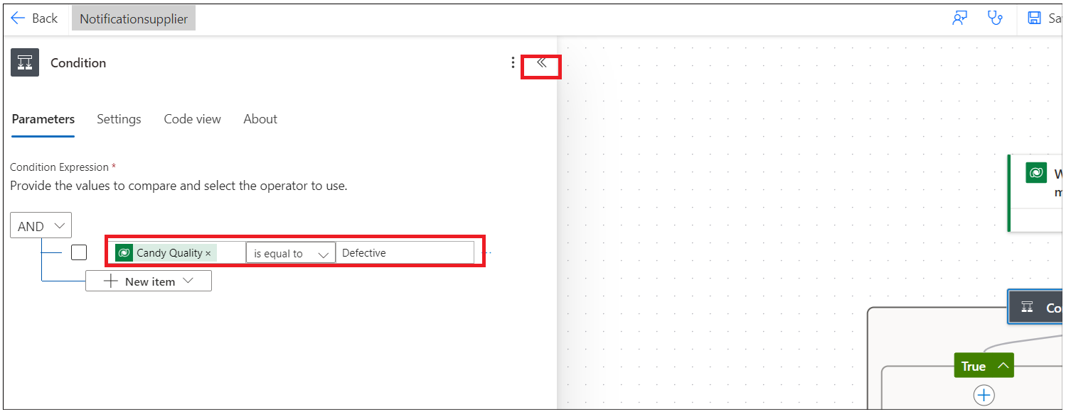

1. Under True condition, click **Add an action**.

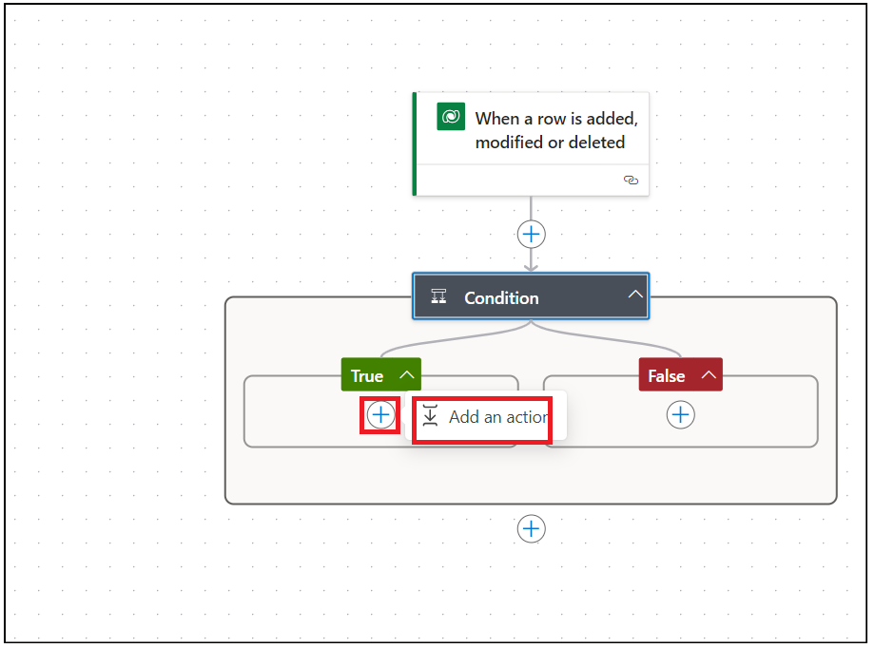

1. Select **Approvals** action.

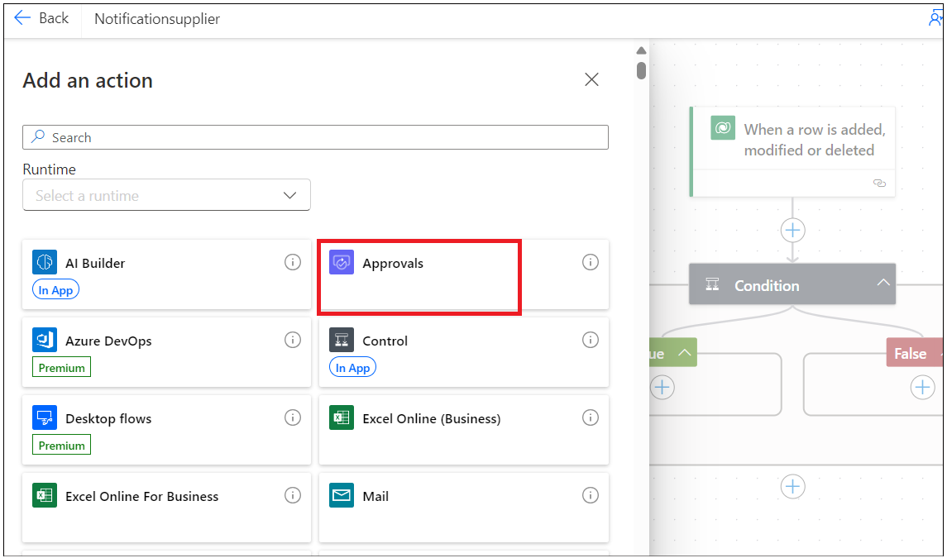

1. Select **Start and wait for approval**.

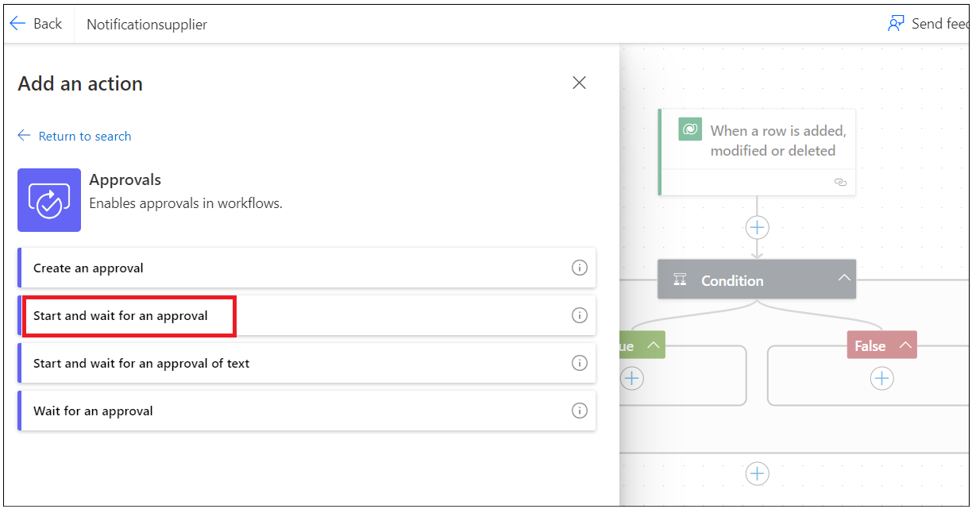

1. If it prompts you for a new connection, click on **the Create new** button.

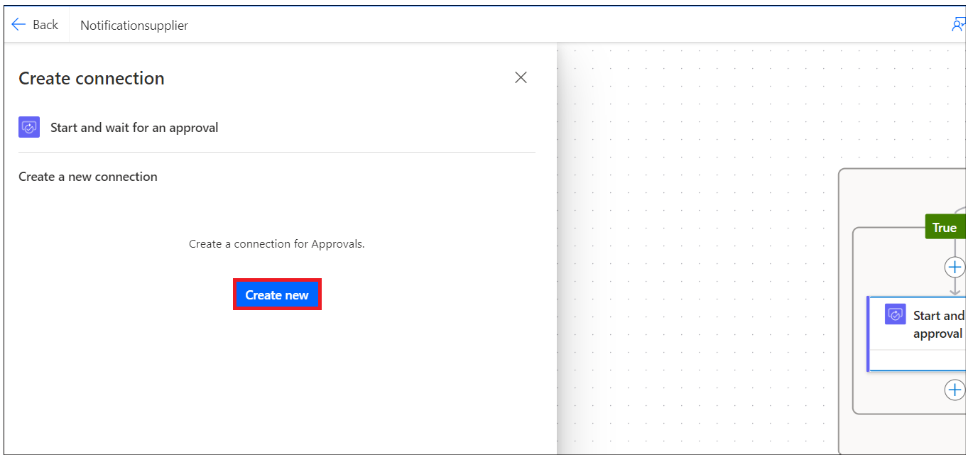

1. Select **Approval Type** as **Approve/Reject – First to Respond**.

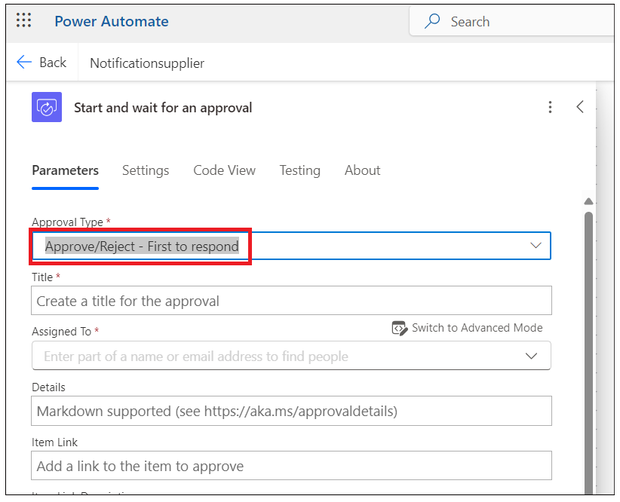

1. Enter the values below and then collapse the window.

Title: **Approve defective product**

Assigned to your workID

Description:

Hi  
  
Product - is defective. Please approve to replace it.  
  
Thanks

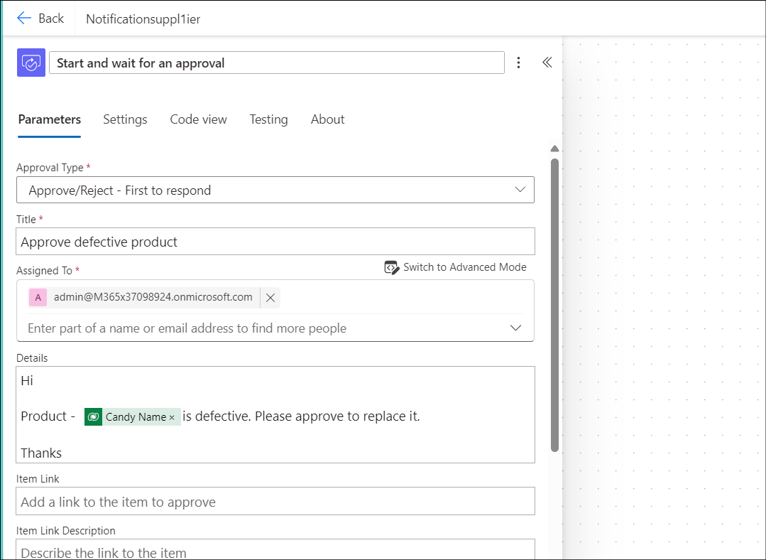

1. Save the flow.

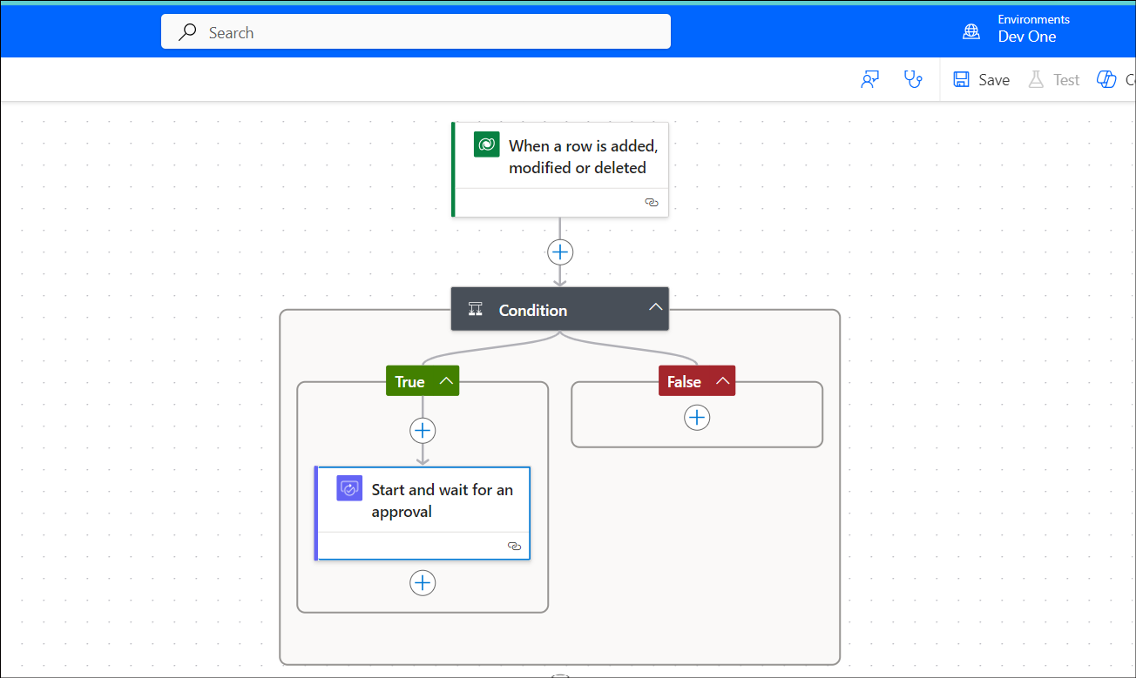

1. Add an action under **False** condition.

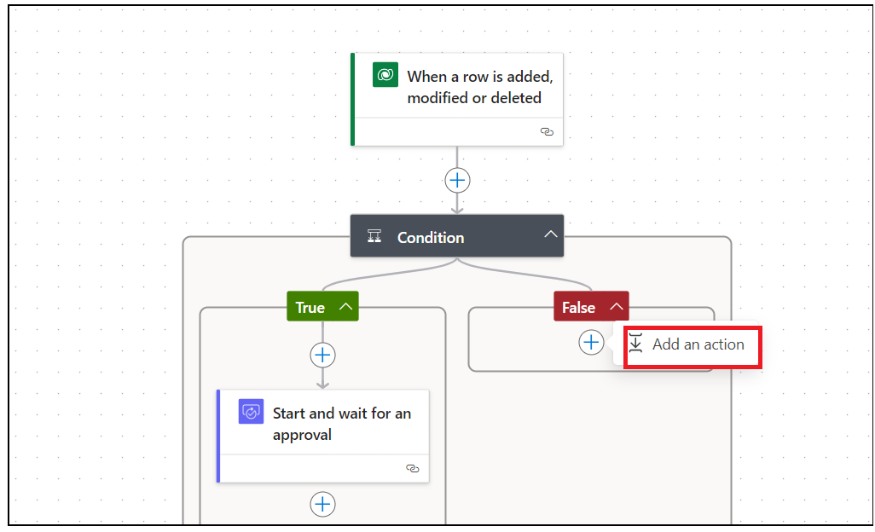

1. Select **Approvals**.

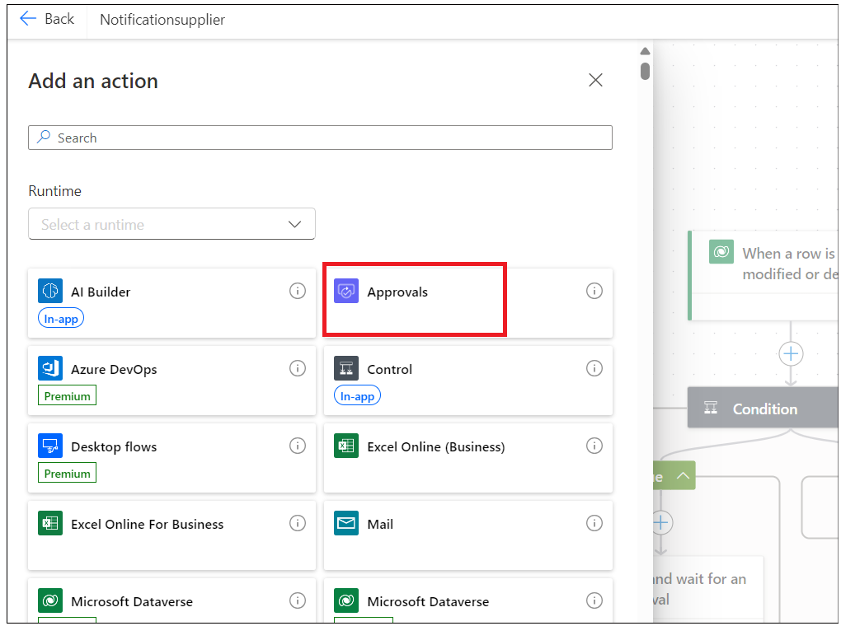

1. Select Start and wait for approval.

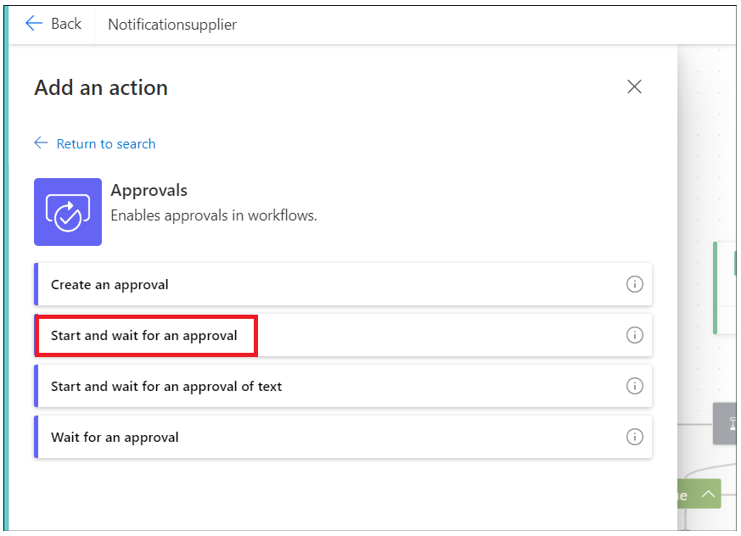

1. Enter below values.

Approval Type: Approve/Reject -First to Respond.

Title - **Non defective product**

Assigned to: Your work/personal email id

Body: Hi,  
  
Product quality check successful. Please approve to add this product to the stock.  
  
Thanks

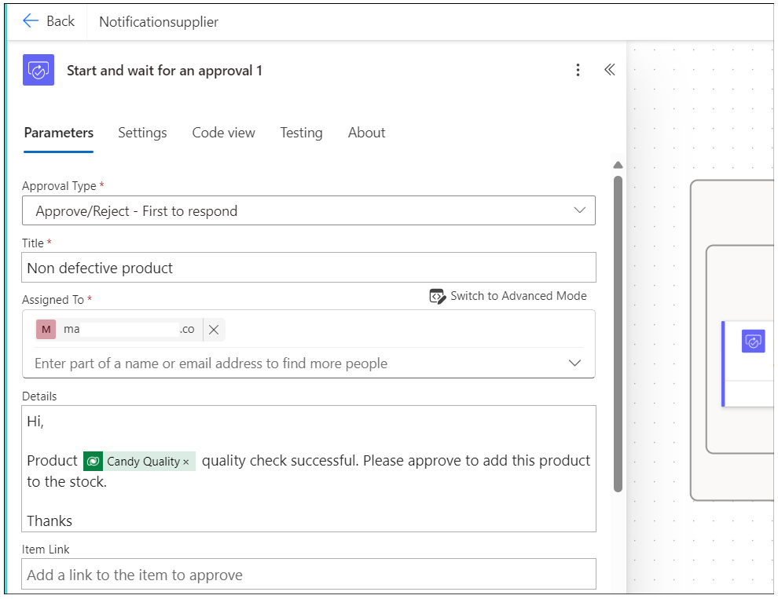

1. Save the flow.

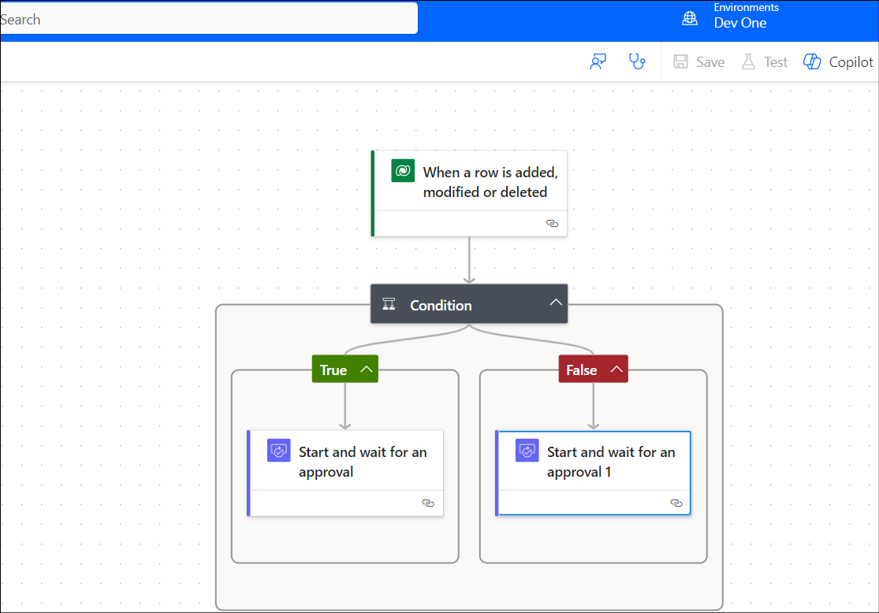

**Note**: Please add more input to your approval requests as per your requirements.

## Task 2: Generate a defective product email to the supplier for approval.

1. Switch back to your Power Apps tab and preview the **Candy** **Qualitychecck** screen. Enter details and select **Candy** **Quality** as **Defective** and then click on the **Submit** button.

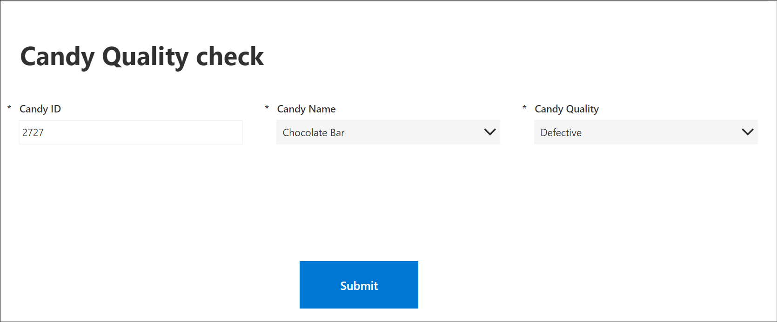

1. Switch back to your Power Automate flow tab and click on **My flows**. Your flow should be in running status.

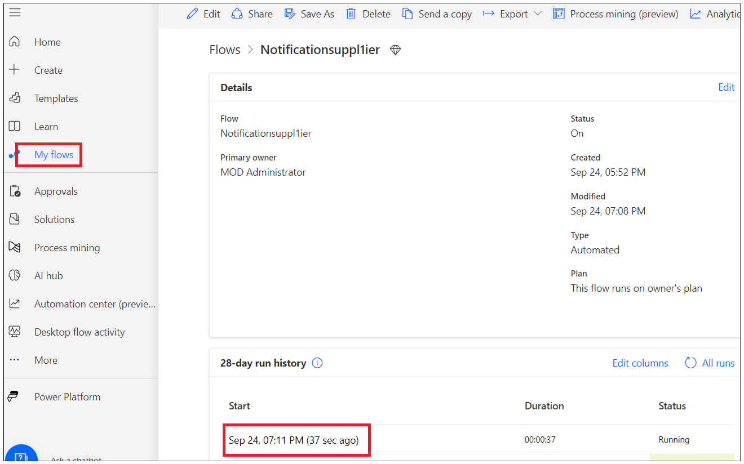

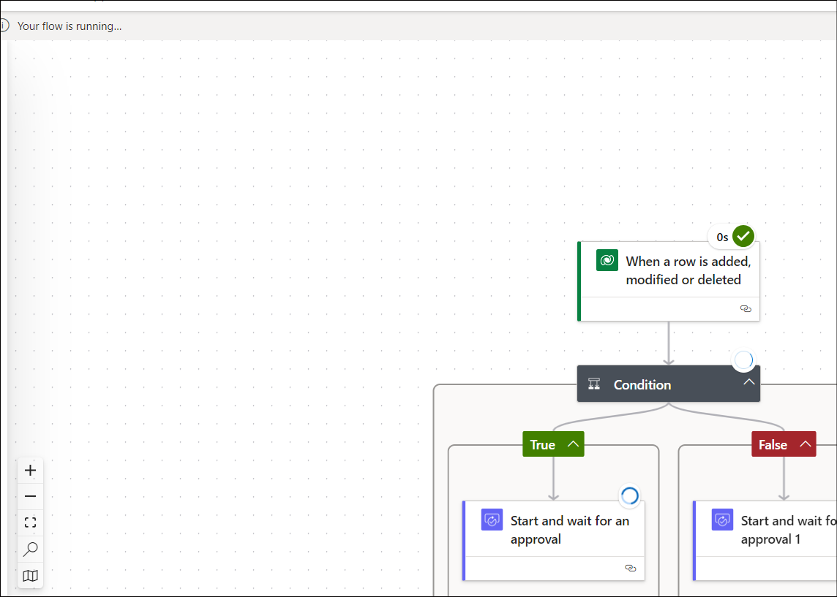

1. Open a new tab in browser and go to <https://outlook.com> and sign in with your work/school/admin account and check email. You should see an email to approve replacement for defective product.

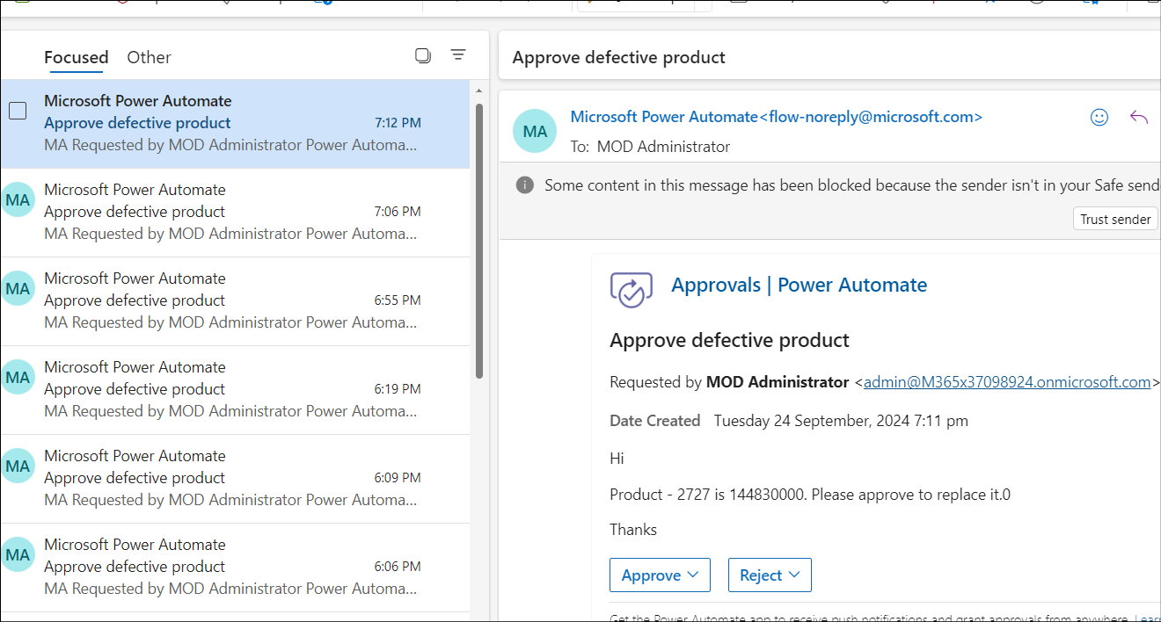

1. Approve/Reject the request to complete the flow.

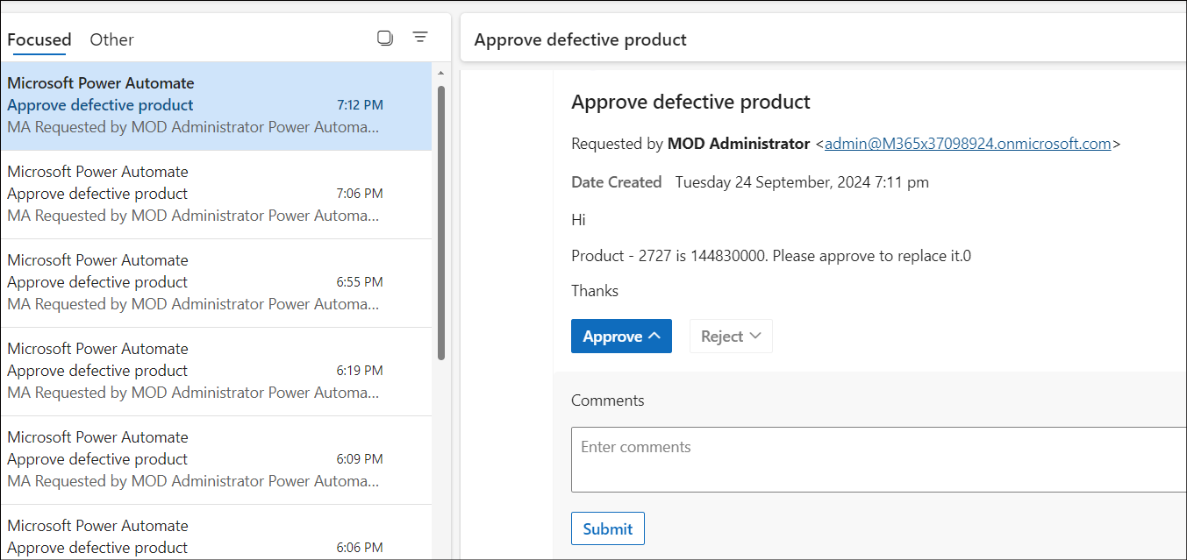

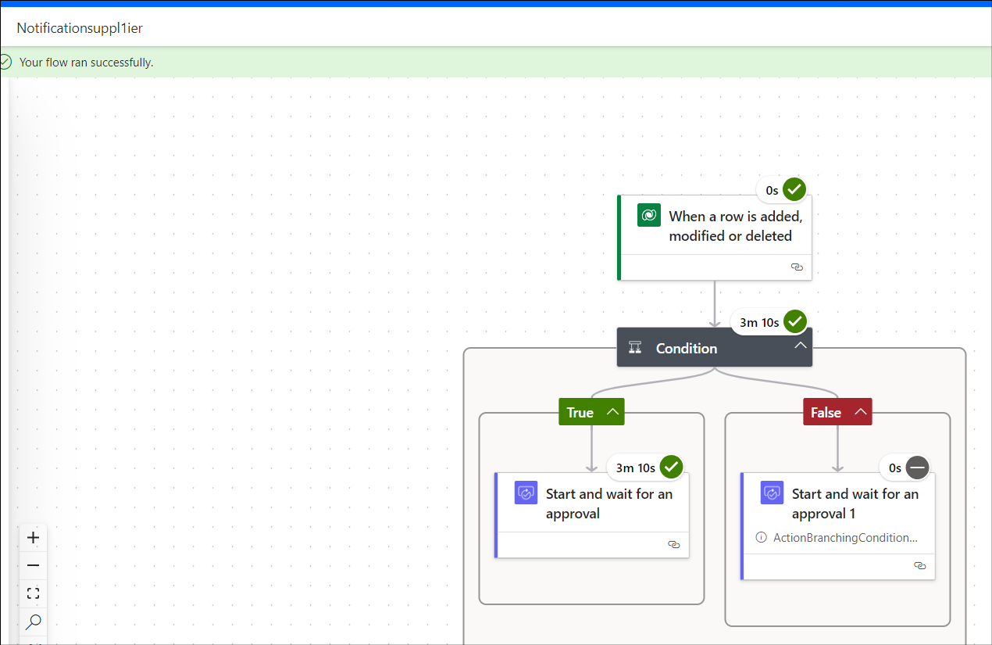

## Conclusion

Power **Automate Cloud Flow for Supplier Notification:**

This flow automates the process of notifying suppliers when an item requires a quality check. When a quality check is triggered, the flow sends an automated notification to the supplier for approval.